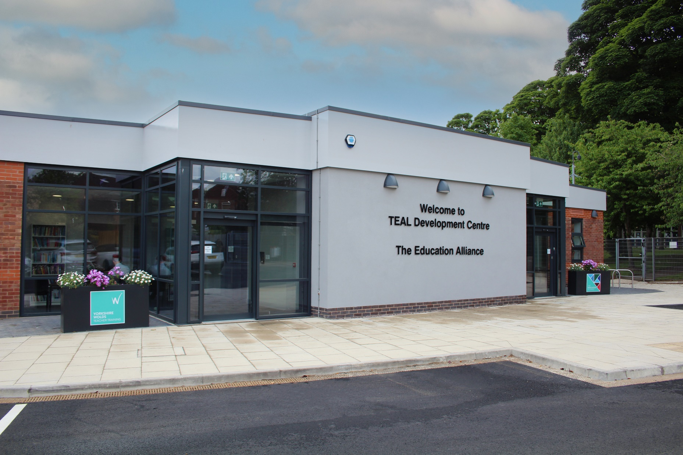

IT Engineer   
Applicant Pack

Contents

Welcome letter from Jonny Uttley CEO 5

About The Education Alliance 6

Our Promise 7

Where We Are 8

What do our Headteachers say about TEAL? 11

What do our staff say about TEAL? 12

What does Ofsted say about TEAL? 13

CPD 14

Be Well 14

Our Structure 15

Our Estates 16

Sustainability 16

[IT Network 18](https://theeducationalliance-my.sharepoint.com/personal/matt_wadsworth_theeducationalliance_org_uk/Documents/7.%20TEAL/Data%20Manager%20Role/TEAL%20Applicant%20Pack%20Trust%20Data%20Manager.docx#_Toc149298010)

Job Description 19

Person Specification 20

Benefits 21

The Recruitment Process 22



***“We are here to make great schools and happier, stronger communities so that people have better lives.”***

# Welcome letter from Jonny Uttley CEO

I would like to welcome you to the Education Alliance. Let me tell you a little bit about us.

Our core purpose is to make great schools and happier, stronger communities so that people have better lives. This underpins everything we do. The way we do this is by: always doing what is right; trusting in each other and standing shoulder to shoulder and doing what we know makes the difference.

We know that staff and pupils only thrive in a positive culture and leaders here create a culture in which staff have an enjoyable, rewarding working environment in which all colleagues believe the demands of their job are reasonable and manageable. It is essential that our schools are led in an ethical way that is driven by moral purpose. The Trust is dedicated to developing, growing and retaining talented leaders and staff across the Trust and we invest heavily in staff development.

We start from an assumption of professional trust and the belief that everyone seeks to do a good job. We operate within a spirit of openness and transparency and staff are encouraged to feel confident to raise any concerns or issues they have. All our staff contribute to developing a thriving culture of openness, honesty and kindness, in which we make each other’s lives better as well of those of our young people.

Included here are our workload charter and ethical leadership framework which will give you a sense of what this means.

TEAL is a family of schools and each school has retained its own identity but is warm and welcoming. We look forward to hearing from you.

Jonny Uttley  
*CEO, The Education Alliance*

**

# About The Education Alliance

The Education Alliance Multi-Academy Trust was established in 2015 and currently comprises of a family of 12 schools with their own unique and individual identities as well as Yorkshire Wolds Teacher Training, the only Outstanding SCITT based in East Yorkshire, which is training a new generation of primary and secondary teachers in East Riding and Hull.

# Our Promise

We recognise that the commitment and care shown by all staff are fundamental to the success of our students and we promise our staff that they will be supported, encouraged, respected and provided with an enjoyable and rewarding working environment. The Education Alliance is dedicated to developing, growing and retaining talented leaders and staff across the trust and nothing is more important than staff development. We want our schools to be places where people want to work and choose to stay. For too long in too many English schools, staff have been asked to choose between being seen as good at their job and being a good mum, dad, partner, son, daughter or friend. We say, “no more”. While we are far from perfect, we will do everything we can to support our staff to balance the demands of their jobs and those at home, and we recognise that in everyone’s life there are good times and bad. It is the job of all of us to support each other through both. In turn, all our schools will have a deep commitment to the entire school system, adding value through collaboration and ensuring that our decisions do not impact negatively on other schools locally or nationally.

We invest heavily in creating a positive culture that is underpinned by our Ethical Leadership Charter Competencies and Behaviours (Trust, Optimism, Kindness, Courage, Service, Wisdom, Justice and Vision) and our Workload Charter. The culture of the trust and our schools is critical in ensuring we have an enjoyable, rewarding working environment in which all colleagues believe the demands of their job are reasonable and manageable.

It is essential that our schools are led in an ethical way that is driven by moral purpose. Many of the difficulties that staff experience in schools come from a high stakes accountability system that can drive leaders to behave in ways that increase stress and anxiety for staff. We insist that our leaders do everything they can to guard against this, that they set a good example in how they behave and that they try to reduce levels of stress and anxiety in the organisation. To support this we offer training and development for our managers and leaders to ensure they are able to translate the vision and values into behaviours which are built on the principles of dignity, respect, professionalism and integrity.

We start from an assumption of professional trust and the belief that everyone seeks to do a good job. We ask all leaders to set a good example in how they behave and that they try to reduce levels of stress and anxiety in the organisation.

Recruitment and retention in schools is becoming increasingly challenging. Evidence shows that workload is cited as the main reason teachers leave the profession. Workload can include various aspects of teachers’ working lives, including marking, planning, preparation, monitoring, evaluation and data collection. The trust recognises it has a duty of care towards its staff and is committed to working with its recognised trade unions to clarify workload expectations, supporting staff to achieve a healthy work-home balance. This commitment is genuine and sincere and it applies to everyone in the trust. Leaders are expected to demonstrate this commitment and to be mindful of what is reasonable for colleagues at all levels of the organisation.

# Where We Are

The Education Alliance is predominantly based in the East Riding of Yorkshire. Our twelve schools have a spread across the locality with Malet Lambert School based in Hull and Naburn CE Primary School based in York. Being in such close proximity to each other ensures that we can share expertise and resources effectively.

“I was attracted to the role as I knew it would give me the opportunity to work with a variety of colleagues across a diverse group of schools, and also develop my knowledge and skills in education. I love meeting and working with lots of different people and I think this really helps build positive relations professionally but also personally. TEAL stands out to me from anywhere else I have worked, a few reasons being that I have a strong network around me with colleagues who are highly supportive and approachable, each day brings a new challenge and something different to the table, the working environment is always funs but professional when it needs to be, and most of all, I feel valued and appreciated as an employee” – **Victoria Dent – Executive Assistant**

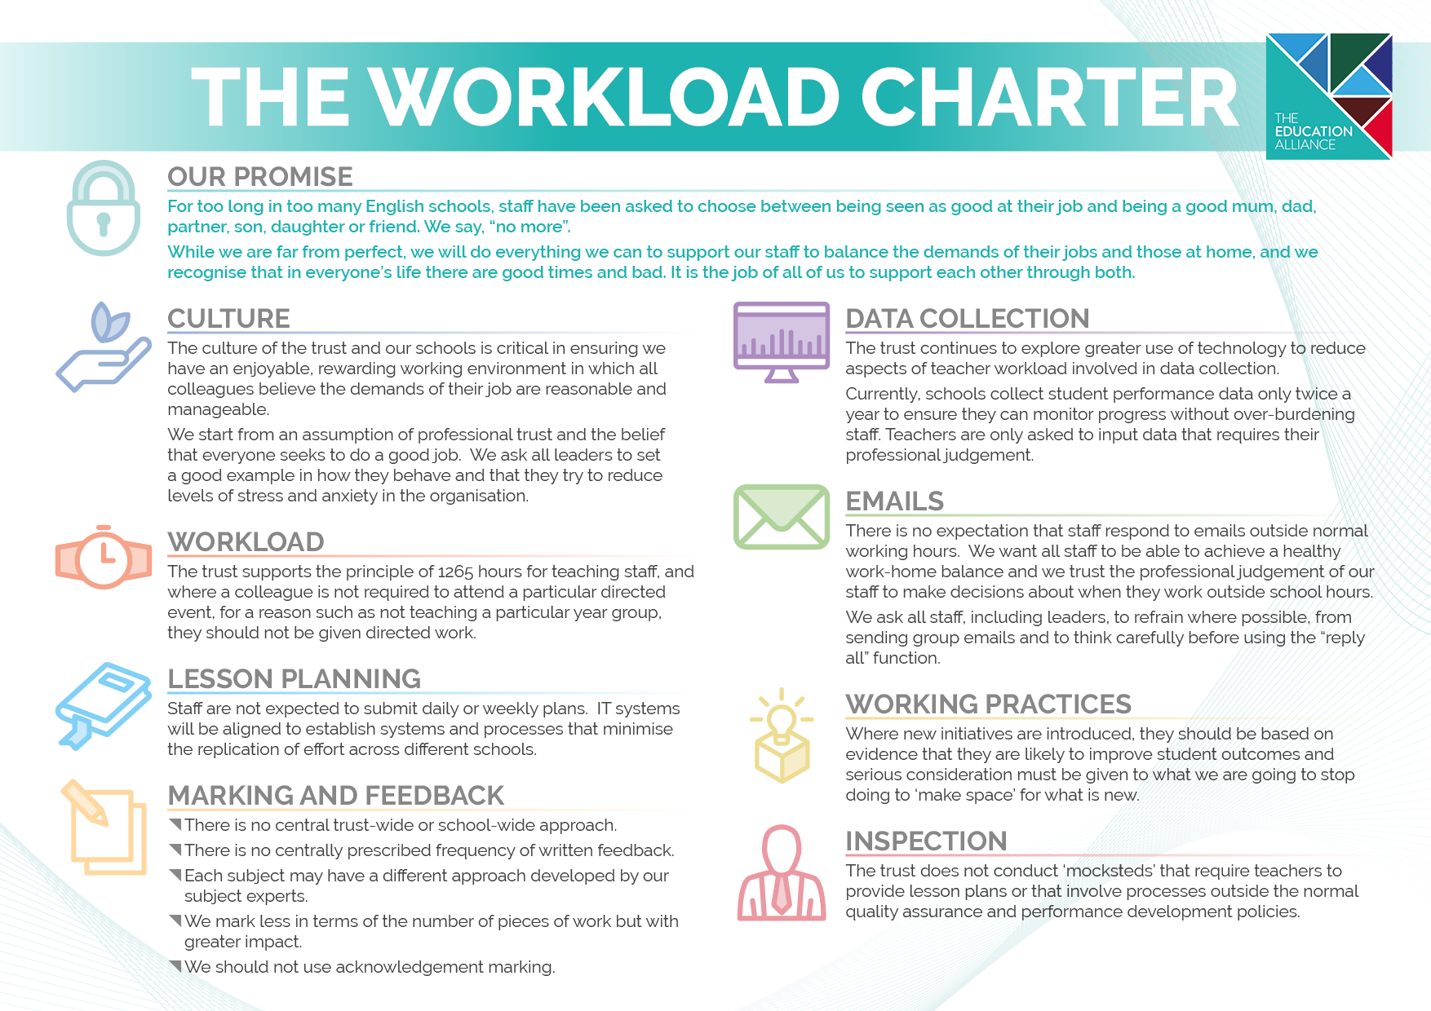

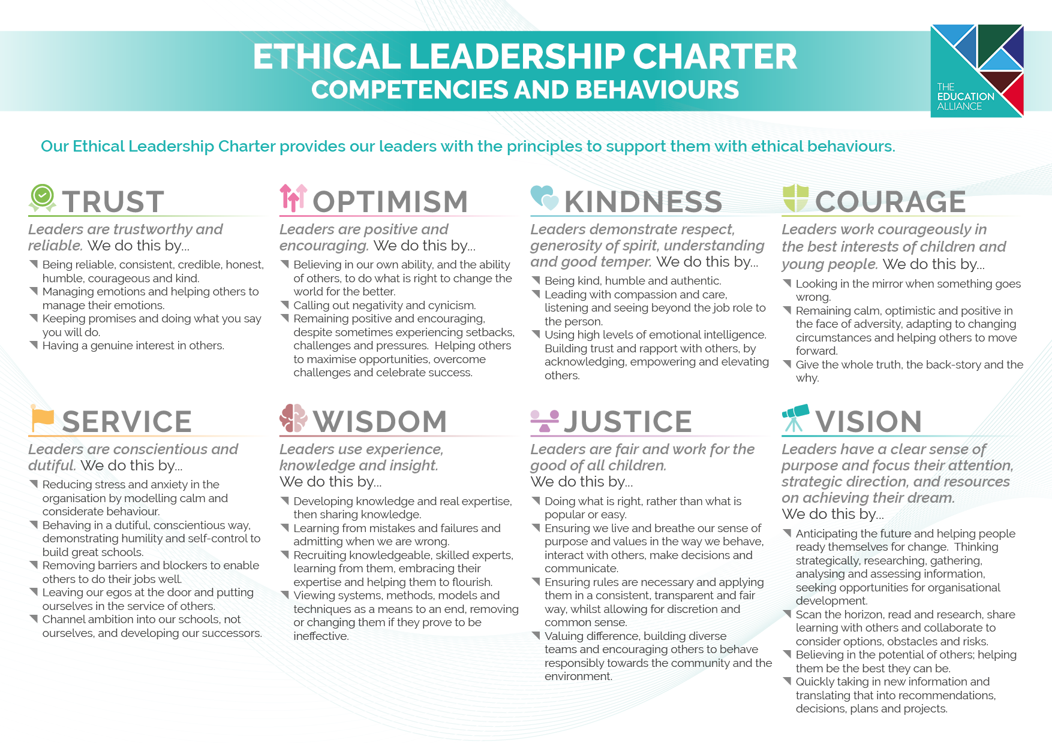

# What do our Headteachers say about TEAL?

Our school joined the Education Alliance in November 2019 and since then we have benefited immensely from working within the Trust. The support has been invaluable on many different levels. Our staff really appreciate working collaboratively with other colleagues within the Trust to develop our curriculum and share training. We have also really valued the support we have received in other areas, such as finance, HR, catering, and premises. We are excited to be part of the Trust moving forward as we continue to enhance the opportunities for our children. – **Richard Winks**

Some say that Headship can be a ‘lonely place’, at times. Not in The Education Alliance! Malet Lambert was lucky to be one of the first schools to join TEAL. The support we receive as a school from the trust team has been crucial in our development. Much of the ‘heavy lifting’ is taken away from schools, which means my leadership team and I can focus more on the day to day running of the school, whilst working alongside trust colleagues strategically. The trust has assisted us in the development of the school, whether it be our curriculum offer, value for money procurement or sustainability, just as a few of many examples. The skillset in the trust team is strong and varied. The size of the trust also allows a very personal offer, where everyone knows everyone else and you very much feel like a valued school rather than just a number. Malet Lambert is a very proud member of TEAL, as am I as a Headteacher. - **Patrick Sprakes**

As headteacher of Hunsley Primary, I have always felt the strength of collaboration and shared moral purpose across the trust's schools to be a powerful support in all aspects of my role. Schools and their leaders will always face both opportunities and challenges - often in equal measure - and it is inspiring to know that no leader in the trust works alone. Instead, we work positively and creatively across a wide team to share one another's successes and to offer thoughtful solutions to questions, inspired by the same values.  As a group of headteachers, our collective understanding and experience mean that we draw on each other readily, in a proper spirit of support and mutual respect. – **Lucy Hudson**

As a new headteacher, being part of TEAL is invaluable. I am part of a wider team of headteachers who I am able to share ideas with, seek advice from and, ultimately, this helps to improve the experiences for all our young people. The advantage of working as a group of schools is that we can share ideas and resources which reduce workload and make people’s lives easier. This reduces the duplication of effort across TEAL and helps us take full advantage of the expertise we have in all of our schools. A wide range of similar groups work together regularly, including whole school curriculum leaders, pastoral leaders and SENDCOs. Whatever your role in TEAL, the opportunity to work with other people across our schools helps us to secure the best experience for our students, whilst keeping workload as manageable as possible. – **Vicky Loftus**

Since joining TEAL officially in October 2022, the benefits to the school have been felt throughout the school. Whether it is the support of the Central Team in taking away some of the 'heavy lifting' around finance, HR, estates, kitchen services, IT or on the ground support/development through weekly on-site visits, as a Headteacher, it feels easier to navigate my day to day duties whilst being able to focus on delivering the best possible provision to our pupils. As a headteacher, one of the barriers to my role was previously having to wait for support or a response to a request - this isn't the case since joining TEAL. Support is forthcoming and quickly available. – **Lee Hill**

# What do our staff say about TEAL?

At our TEAL Annual Teaching and Learning Conference, we asked staff for feedback on questions which had previously been shared by TES:

**Slido Workload Survey**

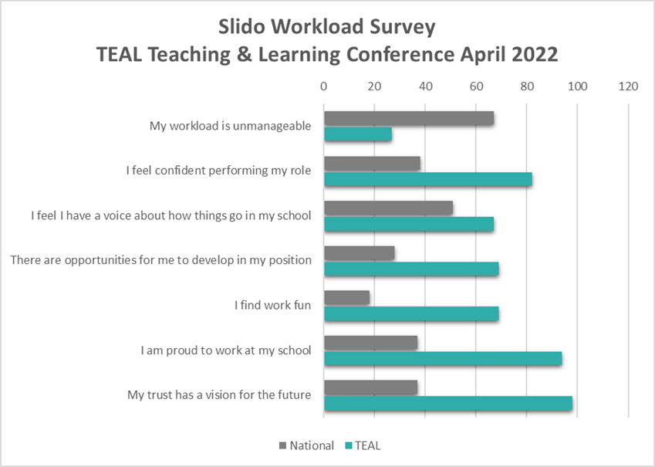

*“My role allows me to work across TEAL, supporting all of our schools alongside collaborating on projects with a variety of stakeholders. Projects can start from the due diligence stage and it is great to have the opportunity to work with incoming schools from an early stage. No two days are the same and I continue to learn and gain experience from every new school that joins the TEAL family.”****–Francesca Roper, Director of Trust Development and Compliance***

# What does Ofsted say about TEAL?

|  |
| --- |
| *“Leaders know that a ‘well’ staff is crucial to meeting the needs of pupils. Subject leaders have the professional autonomy to interpret school teaching policies in ways that are appropriate for their subject. This prevents inefficient use of teacher time. Staff appreciate the commitment to their well-being exemplified by the ‘TEAL workload charter’. They are happy and proud to work at The Snaith School.”* Ofsted, May 2022, **The Snaith School**  “Staff are very proud to work at this school. They feel valued and that the school invests in their professional development. Leaders have ensured that, through the Trust’s workload charter, staff have a good work-life balance. Leaders have ensured that there is time for teachers to hone their skills and the curriculum.” Ofsted, October 2023, **Malet Lambert School**  “Leaders promote well-being for all staff, with a dedicated senior leadership post for this responsibility. Staff are appreciative of the steps taken by leaders to reduce workload. Those with curriculum and leadership responsibilities value the time they are given to develop their roles. Leaders at all levels are proud of the journey of the school.” Ofsted, November 2023, **Hunsley Primary**  “The provider’s core purpose of ‘developing great new teachers’ is highly evident” Ofsted, April 2024, **YWTT** |

*“Leaders prioritise staff well-being. The school has established a workload and ethical leadership charter. Staff report that this has had notable impact. Staff feel well supported and enjoy working at the school. Staff are supported to develop their expertise through a range of tailored training opportunities.” Ofsted, May 2024,* ***South Hunsley School and Sixth Form College***

|  |  |
| --- | --- |
|  |  |

|  |
| --- |
|  |

# CPD

At TEAL we are committed to professional development and we have a number of our team who have already completed or working towards a professional qualification such as an apprenticeship from level 2 up to level 7.



# Be Well

The Be Well programme delivers a whole school approach to supporting mental health and wellbeing for pupils, parents/carers and staff. TEAL invests £250,000 a year from its TEAL Social Value company to provide the following services to schools:

* High quality staff training and support.
  + - A commitment to ensuring we have trained Youth Mental Health First Aiders at a ratio of 50:1 within our schools.
* Listening service for children, parents and staff as a drop-in service, in person or virtually.
* A range of workshops for young people of all ages and parents.
* Access to a high quality training programme for young people who wish to become Well-being Ambassadors.

**100%** of pupils attend a school judged to be   
**Good** or better (inspected as part of TEAL)

# Our Structure

# Our Estates

Our schools Estates are all incredibly different ranging from listed building facades to brand new DfE purpose built Free Schools.

We have a careful and considered 5 year estates strategy and over recent years, we have made a significant investment in our school buildings to ensure we can deliver a first class learning experience which will equip our students with the skills required for work in the 21st Century. Our estates plan is the key driver for the allocation of our School Conditions Allocation funding from the DfE.

We have well equipped computer rooms and Wi-Fi access across all schools and all of our sites have fantastic green spaces and sports facilities.

# Sustainability

“Having previously worked for large private businesses, I was excited to start in a brand-new sector. I knew it would be a fantastic learning opportunity to work amongsta variety of colleauges and schools, building my skillset and knowledge in a new area. Working for TEAL has given me a fantastic work life balance, as I am able to work predominently term time only, allowing me to spend more time with my young family, which is priceless. I have built many positive relationships, and thoroughly enjoy coming to work everyday! ”

**– Lisa Cunningham – Assistant Director of Finance**

TEAL is committed to reducing our impact on the environment and we have a comprehensive sustainability strategy which is led by the Central Services Team who link with our curriculum delivery teams, ensuring that our young people understand the impact of sustainability and what changes are needed to reduce this.

# 

# IT Network

# 

Over the last few years we have been working hard to align our IT networks where appropriate, including a single email system and in the process of moving our document storage online, allowing for sharing and collaborating across our schools.

We are at the beginning stage of implementing a new network template across our schools, pushing a cloud first strategy, to limit the burden of on premise cost and reduce our risk surface area.

# Job Description

|  |
| --- |
| **Job Description: IT Engineer Reporting To: Director of IT**  **Pay Scale: SCP 25**  **Hours of Work: 37 hours pw (8 – 4 Mon – Thu, 8 – 3.30 Fri)**  **Job Purpose:** The purpose of this post is to work as part of a central team to support the IT infrastructure, including LAN, WAN, Wi-Fi, Server, Storage and IT assets. To ensure the smooth running of IT systems to meet the needs of Staff and students on a daily basis across all schools within the trust. Based at The Snaith School, this will be your primary location. |
| **Key Responsibilities:** |
| * E-Safety technical support * Be able to make effective and decisive decisions surrounding IT related technologies * Work as part of a team on large-scale IT projects and liaise with external organisations where required * Lead on presentations to parents and staff related to IT * Liaise with the IT Lead and Director of IT to support the budget in line with school policies and guidelines * Ensure the continuous and effectiveness of the school’s IT infrastructure. * To look after the school’s day to day running of the network and IT systems. * Ensure the school’s IT infrastructure patched and security checked. * Ensure security of data, network access and backup systems. * Windows and software deployment using Microsoft System Center or equivalent deployment applications * Server deployments using Hyper-V and VMWare. * Layer 2 and 3 networking, including VLAN configuration. * Ensure IT assets are recorded and audited. * Act in alignment with user needs and system functionality to contribute to Trusts policies. * Identify problematic areas and implement strategic solutions in time. * To establish a good working relationship with internal and external customers within the trust. * Potential for out of hours working. * Designing and implementing any necessary changes to the school network infrastructure. * Contributing to the development of, and responsible for the implementation of policies, e.g. Backup and Disaster Management * Travelling to sites within the trust to provide technical support in line with the central team’s service level agreement with those sites * Based at a secondary site as primary engineer contact, depending on the sites relevant service level agreement * Work on a rotation within the central team to provide first on the scene checks or last to leave checks and provide feedback to other engineers within the team on findings, to ensure consistency and additional support where required. |
| **Specific:** |
| The post holder will be expected to work within the trust and schools’ policies and procedures and uphold the organisation’s vision. Performing other such duties as reasonably correspond to the general character of the post and are commensurate with its level of responsibility. |
| **The key competencies and behaviours commensurate with this post are identified overleaf.** |
| **General Information:**   * *The job description is not intended to be a complete list of duties and responsibilities but indicates the major requirements of the post. It may be amended at a future time, to take account of the developing needs of the trust. The post holder will undertake any other duties at the request of the Head teacher, appropriate to the remit.* * *The above principal responsibilities are not exhaustive and may vary without changing the character of the job or level of responsibility.* * *The Health and Safety at Work etc. Act, 1974 and other associated legislation places responsibilities for Health and Safety on all employees. Therefore, it is the postholder’s responsibility to take reasonable care for Health and Safety and Welfare of him/herself and other employees in accordance with legislation.* * *The above duties may involve having access to information of a confidential nature, which may be covered by GDPR, and by Part 1 of Schedule 12A to the Local Government Act, 1972. Confidentiality must be maintained at all times.* * *The trust is committed to safeguarding and promoting the welfare of children, young people and vulnerable adults and expects all employees and volunteers to share this commitment.* * *To work and process personal and sensitive information in accordance with Data Protection Act 2018 including the General Data Protection Regulations (GDPR) 2018* * *To ensure work is conducted in a way that protects the safety and security of information (e.g. strong passwords, reporting breaches, securing paper records, securely disposing of records.* |

# Person Specification

|  |  |  |  |  |
| --- | --- | --- | --- | --- |
|  | **JOB REQUIREMENT** | **Essential** | **Preferred** | **\*How assessed** |
| **Qualifications, knowledge and experience** | GCSE / CSE in English and Maths, grade C or above | √ |  |  |
| Higher Education qualification in ICT | √ |  | A |
| Degree Level Qualification in ICT |  | √ | A |
| 2 years’ minimum experience of working in an ICT support role in an education or customer service environment | √ |  | A, I |
| Experience supporting external customers | √ |  | A, I |
| Demonstrate a good working knowledge of network technologies, Microsoft windows server, desktop operating systems and Microsoft Office products. | √ |  | A, I |
| Experience of working with Linux Servers and using server-based virtualisation technology. |  |  |  |
| Experience using backup and disaster recovery products for both physical and virtual environments. | √ |  | A, I |
| Experience of managing a technical project from design to implementation | √ |  |  |
| Demonstrable working experience of the following is essential:   * Computer programming * L2 and L3 networking protocols * E-mail services – Office 365 * Wireless networking technology * Web filtering and firewall configuration * Network storage devices and protocols, i.e. SAN, NAS, iSCSI * Group Policy Management * Imaging end user devices on a large scale * Server 2012R2, 2016, 2019, DNS, DHCP, VOIP, Microsoft Active Directory, Entra, Intune | √ |  | A, I |
| Experience of working with / knowledge of the following is essential:   * Configuration management applications and Mobile Device Management software such as Microsoft SCCM, Intune * Volume Licensing * VMware and Veeam * Cloud technologies e.g. Google Apps, SharePoint, Asset management, email filters * Print management software e.g. Papercut * Apple operating systems – Mac OSX, iOS | √ |  | A, I |
|  | Knowledge of school management systems i.e. Arbor /knowledge of database management i.e. MS SQL |  | √ | A, I |
| **Personal and interpersonal** | **Interacting and Presenting - Presenting and Communicating Information**  Speaks clearly and fluently. Expresses Opinions, information and key points of an argument clearly. Makes presentations and undertakes public speaking with skill and confidence. Responds quickly to the needs of an audience and to their reactions and feedback. Projects credibility. | √ |  | A & I |
| **Organising and Executing - Planning and Organising**  Sets clearly defined objectives. Plans activities and projects well in advance and takes account of possible changing circumstances. Manages time effectively. Identifies and organises resources needed to accomplish tasks. Monitors performance against deadlines and milestones. | √ |  | A & I |
| **Creating and Conceptualising – Learning and Researching**  Rapidly learns new tasks and quickly commits information to memory. Gathers comprehensive information to support decision making. Demonstrates a rapid understanding of newly presented information. Encourages an organisational learning approach (i.e. learns from successes and failures and seeks staff and customer feedback). Manages knowledge (collects, catalogues and disseminates knowledge of use to the organisation). | √ |  | I |
| **Supporting and Co-operating – Working with People**  Demonstrates an interest in and understanding of others. Adapts to the team and builds team spirit. Recognises and rewards the contribution of others. Listens, consults others and communicates proactively. Supports and cares for others. Develops and openly communicates self-insight. | √ |  | I |
| **Adapting and Coping – Adapting and responding to change.**  Adapts to changing circumstances. Accepts new ideas and change initiatives. Adapts interpersonal style to suit different people or situations. Shows respect and sensitivity towards cultural and religious difference. Deals with ambiguity, making positive use of the opportunities it presents. | √ |  | I |
| **Adapting and Coping - Coping with Pressures and Setbacks**  Works productively in a pressurised environment; keeps emotions under control during difficult situations; balances the demands of a work life and a personal life; maintains a positive outlook at work; handles feedback well and learns from it. | √ |  | I |
| **Child Protection** | A commitment to the responsibility of safeguarding and promoting the welfare of young people. | √ |  | A & I |
| Enhanced DBS disclosure *(to be completed by preferred candidate following interview).* | √ |  |  |
| Willingness to undertake safeguarding training when required. | √ |  | I |

# Benefits

Here at The Education Alliance we are committed to supporting our entire workforce. Alongside our ethical leadership and workload charter we offer a range of benefits which include:

### Dedicated development time to support you in your role and to allow you to gain additional qualified certifications. For example, Microsoft’s certifications).

* Access to the Team TEAL benefits platform in partnership with Vivup, giving access to a car salary sacrifice scheme, a cycle to work scheme, access to Wagestream and other lifestyle benefits which will allow staff to save money.
* Free Flu vaccinations held on site each year.
* Refund of the cost of an Annual NHS Prescription Prepayment Certificate.
* Regular staff surveys and opportunities to engage in focus groups encouraging staff to be involved in shaping the future of the school and the trust.
* In school individual support from Mind as part of the school’s Whole School Approach to Mental Health and Well Being.
* An induction programme and continued investment in training and development, with access to coaching and mentoring, career and professional development.
* Family friendly policies and opportunities for flexible working, with a trust commitment to continually look to ways to improve the work-life balance for our staff.
* Free parking and good transport links.
* Automatic membership of the Local Government Pension Scheme and the Teachers’ Pension Scheme.
* Recognition of continuous service if you join us from another school, academy or local government employer.
* Hot and cold snacks and meals available from our canteens and complimentary lunches when on lunch duty and training days.
* Free tea and coffee in all of our staffrooms.
* Corporate membership to the East Riding Leisure gyms, saving over 25% on membership costs and onsite gym at South Hunsley School and Sixth Form College, at only £12.50 per month.
* Employee Assistance Scheme available 24/7 via telephone or on-line portal, providing advice on assistance on a wide range of practical issues ranging from legal information and consumer issues to specialist counselling. This now includes a GP appointment service which allows staff and their immediate families to access a GP appointment within 24 hours.

# The Recruitment Process

If you are interested in this role, or would like someone to phone you to discuss the role further, please contact our HR team at [hr@theeducationalliance.org.uk](mailto:hr@theeducationalliance.org.uk) .

The deadline for your completed application forms is **9am on Monday 30th September 2024**.  We look forward to receiving your application and will contact you once your application has been reviewed, should you be called for interview.

*The Education Alliance is committed to safeguarding and promoting the welfare of children and young people. Clearance from the Disclosure and Barring Service prior to appointment and we undertake an online check, in line with the Keeping Children Safe in Education 2024 guidance.*



**The Education Alliance**

East Dale Road

Melton

North Ferriby

HU14 3HS



**01482 636720**



**theeducationalliance.org.uk**