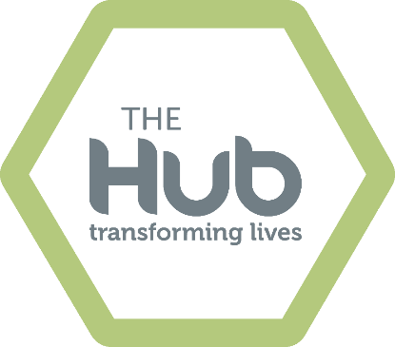


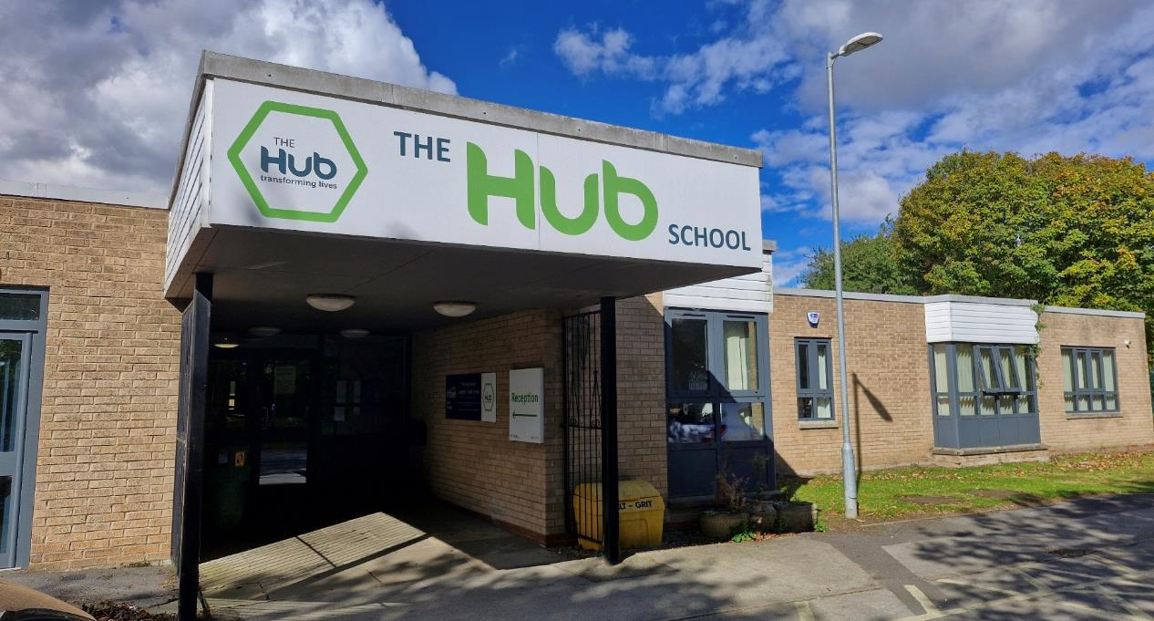
Applicant Pack
Contents
About The Hub 3
Introduction from the Headteacher 4
About TEAL 5
Employee Benefits 8

About The Hub
The Hub School is a school which offers a full-time education for young people who require an alternative setting to that of a mainstream school. The school has two distinct elements: A specialist setting for students with an Education, Health & Care Plan (EHCP) with a primary need of Social, Emotional & Mental Health Needs, alongside a Pupil Referral Unit to support mainstream schools for young people who are finding it difficult to achieve success in a mainstream school environment.
We have two sites, one at Anlaby (for 70 students) and one at Welton (for 20 students). We also use a number of alternative educational providers around East Riding and Hull, who specialise in a vocational curriculum pathway.
We provide our students with an alternative educational experience that offers them a nurturing, safe and supportive environment, with a diverse, qualified and experienced staff team and highly personalised learning. We support our students to accelerate their academic, social and emotional skills development and ultimately enable them to re-engage with learning within a mainstream setting. Our curriculum creates valuable opportunities to nurture our students’ resilience, self-confidence, self-esteem and self-belief.
At the Hub School we recognise that each student has their own strengths and talents, and we aim to provide a personalised approach to learning wherever possible. We understand that some young people find aspects of mainstream education challenging and that some barriers to learning cannot be addressed without specialised support.
We hope to provide the structure and support needed to allow each student to be successful and realise their full potential. Through a broad curriculum, highly skilled staff and child-centred values, we provide a positive learning environment which promotes independence and achievement.

Introduction from the Headteacher
Thank you for your interest in working at The Hub School. I hope that, after reading the information provided, you will feel not only encouraged to apply, but excited by the difference you can make and the opportunities that the school has to offer.
I have been a Senior Leader since 2012, working in North Lincolnshire at the highest-performing school within the authority before moving to the East Riding in 2016 as an Assistant Headteacher. This role supported my passion for Inclusion and gave me an opportunity to follow my core belief that education can, and should be, truly inclusive for all.
I became Headteacher at The Hub School in April 2019. The staff and governance of the school have worked extremely hard over the last few years to change the culture of the school to what you would see today: a positive and welcoming school environment, where we recognise and celebrate differences, have high expectations and ambitions for our students and do everything we can to ensure our students thrive and develop as people, as well as learners.
At The Hub School we are passionate about improving the life chances of our young people and we want all of our students to leave us with the best possible outcomes, memorable experiences and life skills. I feel extremely privileged to be the Headteacher of this wonderful school and be able to lead the school through the next stage of its exciting journey. The Hub School offers a great opportunity for colleagues who are passionate about making a difference in a unique school, within a supportive Trust.
We pride ourselves on a staff culture of support and togetherness. We actively recognise supporting staff workload and wellbeing and encourage a healthy work-life balance. Relationships are at the heart of everything we do. The job satisfaction of making a positive difference to some of the most vulnerable students in the East Riding, and truly effecting change, should be the key motivating factor for wanting to join our fantastic group of staff.
This is undoubtedly an exciting time to join The Hub School and the Education Alliance. We very much look forward to hearing from you and thank you for your interest in our school.
Best wishes
Paul Grimes
Executive Headteacher, The Hub School


About TEAL
Our core purpose is to make great schools and happier, stronger communities so that people have better lives. This underpins everything we do. The way we do this is by: always doing what is right; trusting in each other and standing shoulder to shoulder and doing what we know makes the difference.
We know that staff and pupils only thrive in a positive culture and leaders here create a culture in which staff have an enjoyable, rewarding working environment in which all colleagues believe the demands of their job are reasonable and manageable. It is essential that our schools are led in an ethical way that is driven by moral purpose. The Trust is dedicated to developing, growing and retaining talented leaders and staff across the Trust and we invest heavily in staff development.
We start from an assumption of professional trust and the belief that everyone seeks to do a good job. We operate within a spirit of openness and transparency and staff are encouraged to feel confident to raise any concerns or issues they have. All our staff contribute to developing a thriving culture of openness, honesty and kindness, in which we make each other’s lives better as well of those of our young people.
Included here are our workload charter and ethical leadership framework which will give you a sense of what this means.
TEAL is a family of schools and each school has retained its own identity but is warm and welcoming. We look forward to hearing from you.
Jonny Uttley
CEO, The Education Alliance


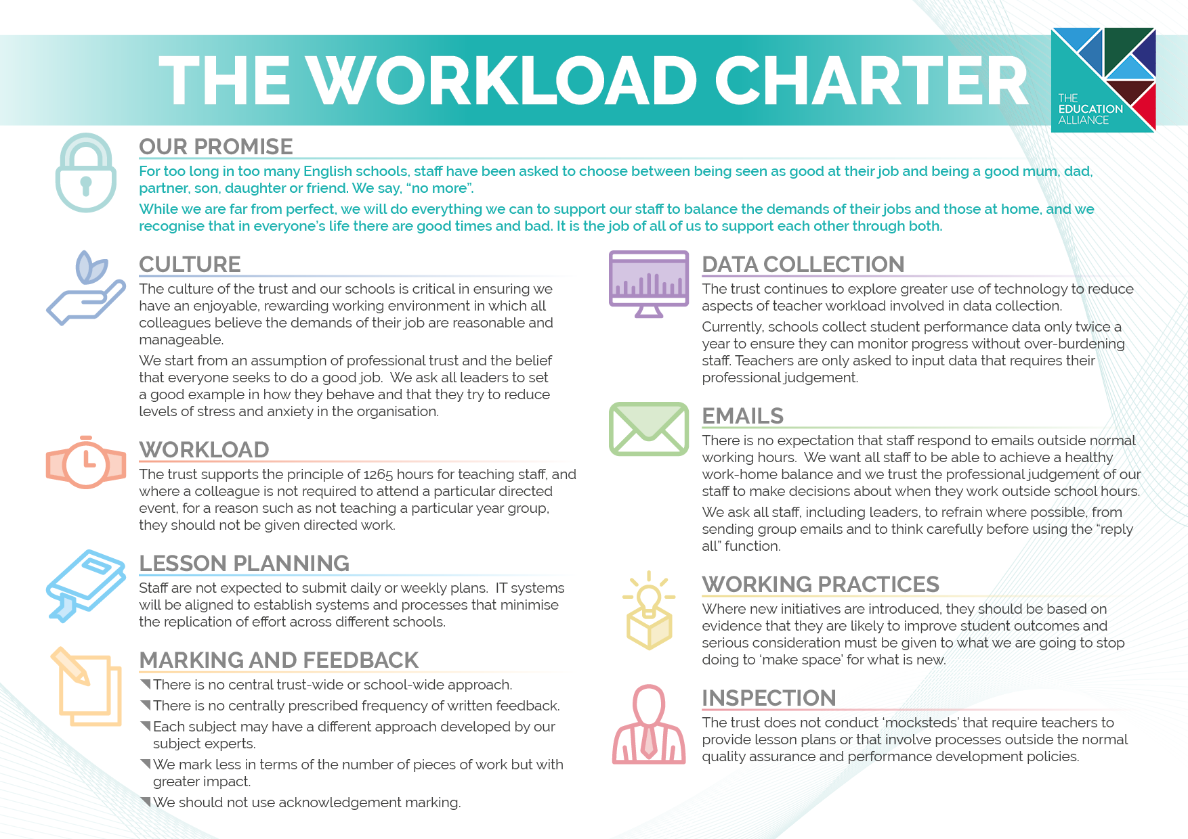

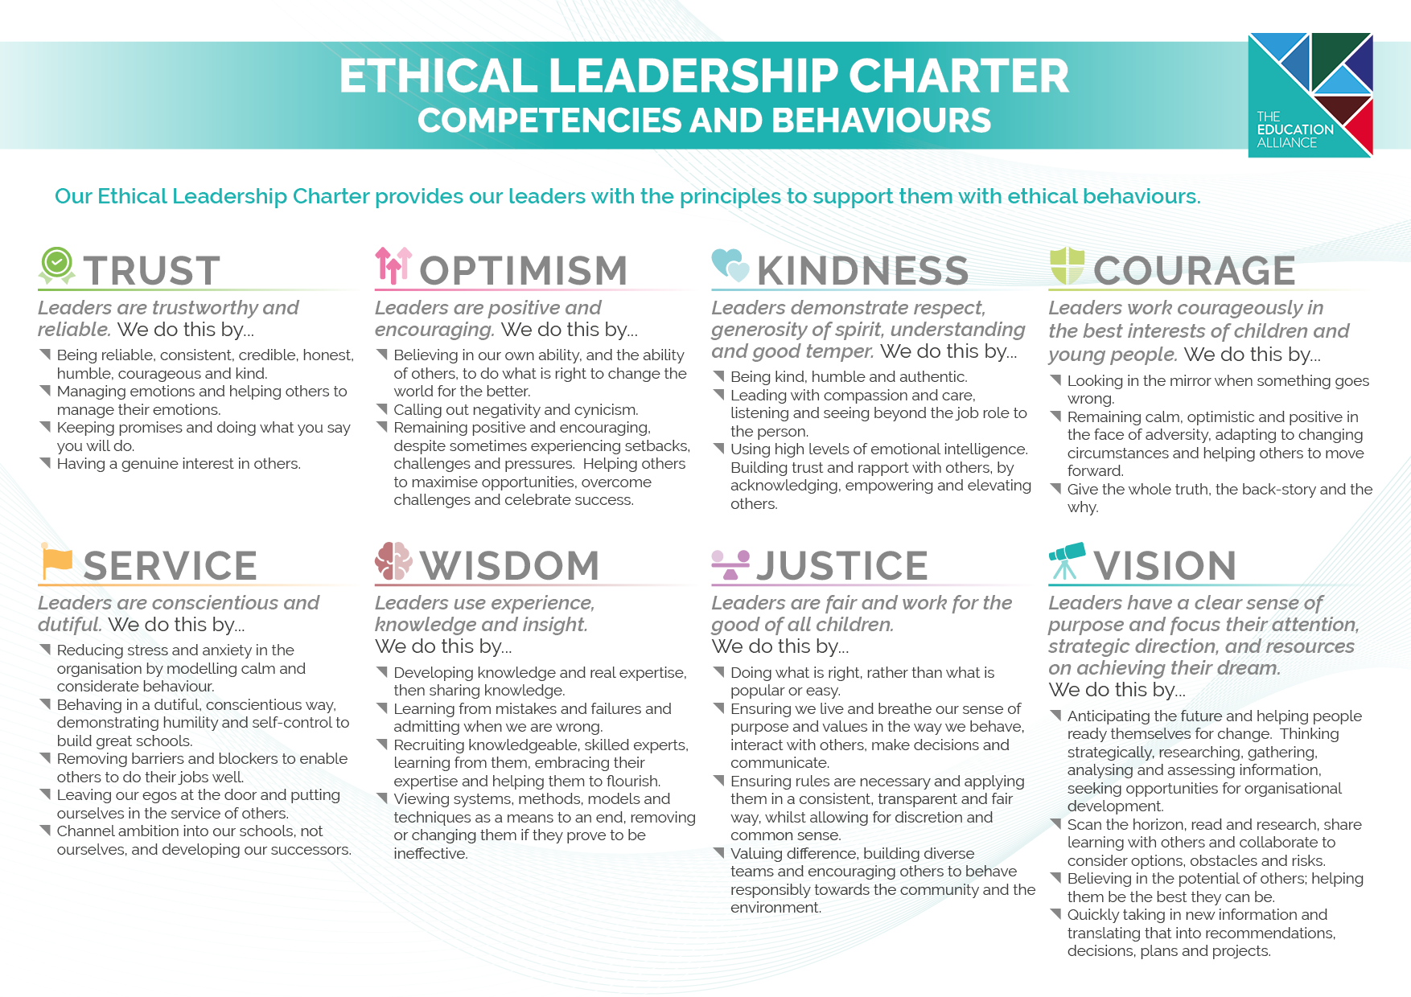

Employee Benefits

Here at The Education Alliance we are committed to supporting our entire workforce. Alongside our ethical leadership and workload charter we offer a range of benefits which include:
- Access to the TeamTEAL benefits platform in partnership with Vivup, giving access to a car salary sacrifice scheme, a cycle to work scheme, access to Wagestream and other lifestyle benefits which will allow staff to save money.
- Free Flu vaccinations held on site each year.
- Refund of the cost of an Annual NHS Prescription Prepayment Certificate.
- Regular staff surveys and opportunities to engage in focus groups encouraging staff to be involved in shaping the future of the school and the trust.
- In school individual support from Mind as part of the school’s Whole School Approach to Mental Health and Well Being.
- An induction programme and continued investment in training and development, with access to coaching and mentoring, career and professional development.
- Family friendly policies and opportunities for flexible working, with a trust commitment to continually look to ways to improve the work-life balance for our staff.
- Free parking and good transport links.
- Automatic membership of the Local Government Pension Scheme and the Teachers’ Pension Scheme.
- Recognition of continuous service if you join us from another school, academy or local government employer.
- Free tea and coffee in all of our staffrooms.
- Corporate membership to the East Riding Leisure gyms, saving over 25% on membership costs and onsite gym at South Hunsley School and Sixth Form College, at only £12.50 per month.
- Employee Assistance Scheme available 24/7 via telephone or on-line portal, providing advice on assistance on a wide range of practical issues ranging from legal information and consumer issues to specialist counselling. This now includes a GP appointment service which allows staff and their immediate families to access a GP appointment within 24 hours.


The Hub School
Springhead Lane
Anlaby Common
East Riding of Yorkshire
HU5 5YJ


01482 304200


www.thehubschool.org.uk

