
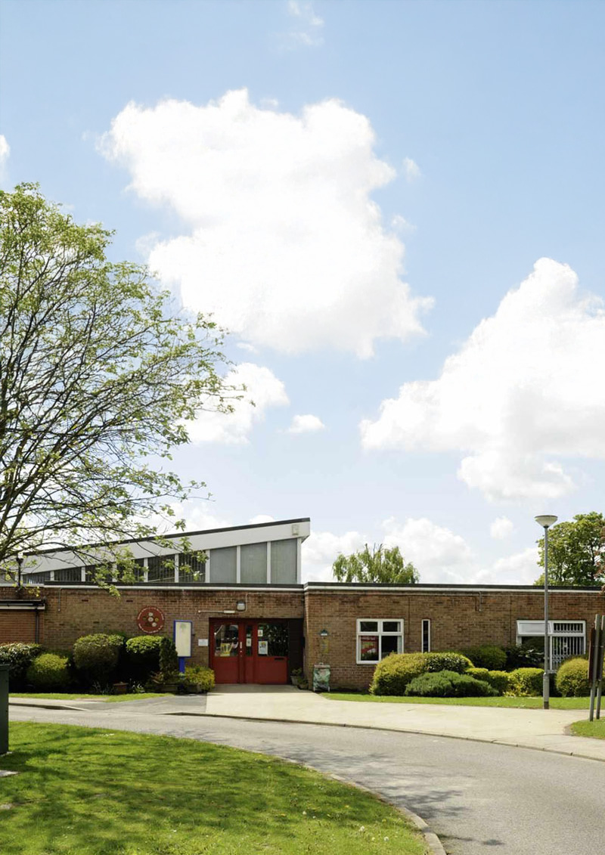



Headteacher
Applicant
Pack

Contents
Welcome letter from Jonny Uttley, CEO 4
About The Education Alliance 5
Our promise 6
Where we are 7
About Howden C of E Infant School 9
Diocese of York 10
About the role and School Improvement 11
Be Well 13
TEAL Central Team 14
What do TEAL headteachers say? 15
What do our staff say about TEAL? 17
The Local Area 18
The Recruitment Process 19
Job Description 20
Person Specification 21

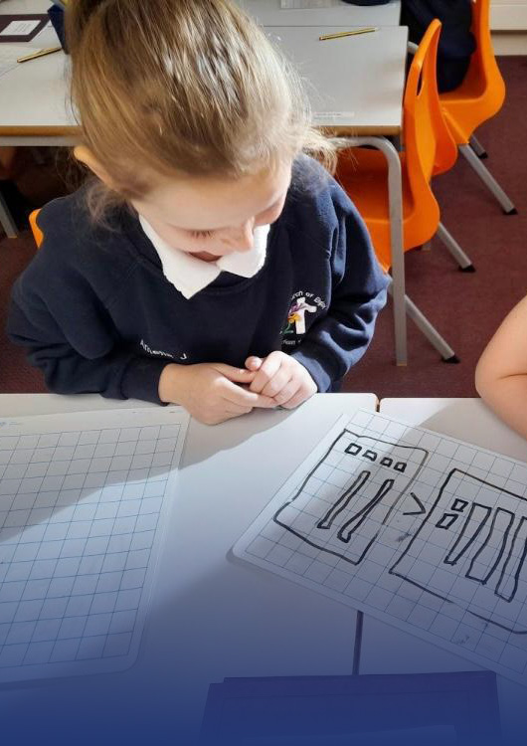

“We are here to make great schools and happier, stronger communities so that people have better lives.”


Welcome letter from Jonny Uttley, CEO
I would like to welcome you to the Education Alliance; let me tell you a little bit about us.
Our core purpose is to make great schools and happier, stronger communities so that people have better lives. This underpins everything we do. The way we do this is by: always doing what is right; standing shoulder-to-shoulder; and focussing on quality in everything we do.
Within TEAL, we advance high-quality inclusive education that values all young people equally. We achieve this by ensuring all schools in the TEAL family are successful and all our young people thrive, as well as developing the next generation of great teachers and leaders. Moreover, TEAL connects with civic leaders, influencing the system so that it becomes more equitable, inclusive, sustainable and ethical.
Included here are our Workload Charter and Ethical Behaviours Charter, which will give you a sense of how this vision and purpose is reflected in our approach.
We look forward to hearing from you.
Jonny Uttley
CEO, The Education Alliance



About The Education Alliance
The Education Alliance Multi-Academy Trust was established in 2015 so that South Hunsley School and Sixth Form College could support the setting up of Hunsley Primary School, the East Riding’s first Free School. Since then, a further ten schools in the region have joined:
2015
} South Hunsley School and Sixth Form College
} Hunsley Primary
February 2016
Malet Lambert |
February 2017
} Driffield School and Sixth Form
April 2019
The Snaith School |
November 2019
} North Cave CE Primary School
October 2022
Howden Junior School |
May 2023
} Wilberfoss CE Primary School
September 2023
Howden CE Infant School |
October 2023
} Naburn CE Primary School
December 2023
The Hub School |
May 2024
} Beverley Minster CE Primary School

In addition to the twelve schools, the trust also operates Yorkshire Wolds Teacher Training, the only Outstanding SCITT based in East Yorkshire, which is training a new generation of primary and secondary teachers in East Riding and Hull.

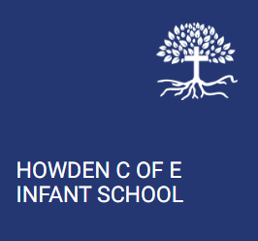


Our promise
We recognise that the commitment and care of all staff are fundamental to our pupils’ success; therefore, we promise our staff that they will be supported, encouraged, respected and provided with an enjoyable and rewarding working environment.

The Education Alliance is dedicated to developing, growing and retaining talented leaders and staff across the trust, with staff development a critical element of this. We want our schools to be places where people want to work and choose to stay. For too long, in too many English schools, staff have been asked to choose between being seen as good at their job and being a good mum, dad, partner, son, daughter or friend. We say: “no more”.

While we are far from perfect, we will do everything we can to support our staff to balance the demands of their jobs and those at home, recognising there are good times and bad in everyone’s life. It is our job to support each other through both. In turn, all our schools will have a deep commitment to the entire school system, adding value through collaboration and ensuring that our decisions do not impact negatively on other schools (locally or nationally).

We invest heavily in creating a positive culture that is underpinned by our Ethical Behaviours Charter (centred around Trust, Optimism, Kindness, Courage, Service, Wisdom, Justice and Vision) and our Workload Charter. The culture of the trust and our schools is critical in ensuring we have an enjoyable, rewarding working environment in which all colleagues believe the demands of their job are reasonable and manageable.

It is essential that our schools are led in an ethical way that is driven by moral purpose. Many of the difficulties that staff experience in schools come from a high stakes accountability system that can drive leaders to behave in ways that increase stress and anxiety for staff. At TEAL, however, we start from an assumption of professional trust and the belief that everyone seeks to do a good job. We insist that our leaders do everything they can to guard against this, setting a good example in how they behave and trying to reduce levels of stress and anxiety in the organisation. To support this, we offer training and development for our managers and leaders to ensure they are able to translate the vision and values into day-to-day practices and behaviours.

Recruitment and retention in schools is becoming increasingly challenging. Evidence shows that workload is cited as the main reason teachers leave the profession. Workload can include various aspects of teachers’ working lives (including marking, planning, preparation, monitoring, evaluation and data collection). TEAL recognises its duty of care towards its staff and is committed to working with its recognised trade unions to clarify workload expectations, supporting staff to achieve a healthy work-home balance. This commitment is genuine and sincere, applying to everyone in the trust. Leaders are expected to demonstrate this commitment and to be mindful of what is reasonable for colleagues at all levels of the organisation.

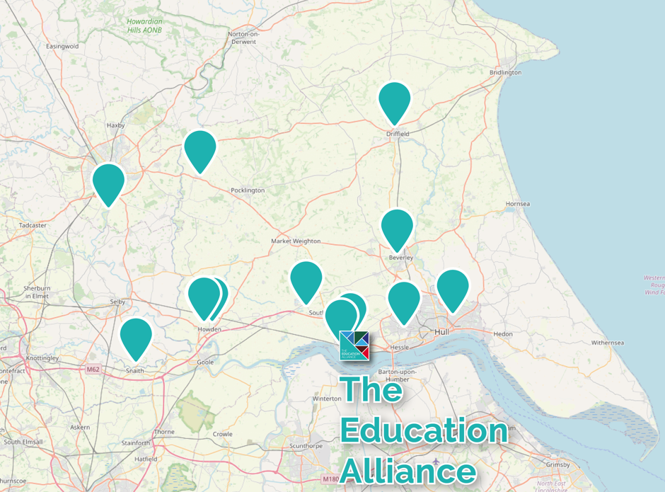
Where we are

The Education Alliance is predominantly based in the East Riding of Yorkshire. Our twelve schools have a spread across the locality with Malet Lambert School, based in Hull, and Naburn CE Primary School, based in York. Being in such proximity to each other ensures that we can share expertise and resources effectively.
“I was attracted to the role as I knew it would give me the opportunity to work with a variety of colleagues across a diverse group of schools and develop my knowledge in the education sector. I love meeting and working with a variety of people and think this really helps build positive relations professionally but also personally. TEAL stands out to me from anywhere else I have worked, a few reasons being that I have a strong network around me with colleagues who are highly supportive and approachable, each day brings a new challenge and something different to the table, the working environment is always fun but professional when it needs to be, and most of all, I feel valued and appreciated as an employee.”
– Victoria Dent, Chief of Staff
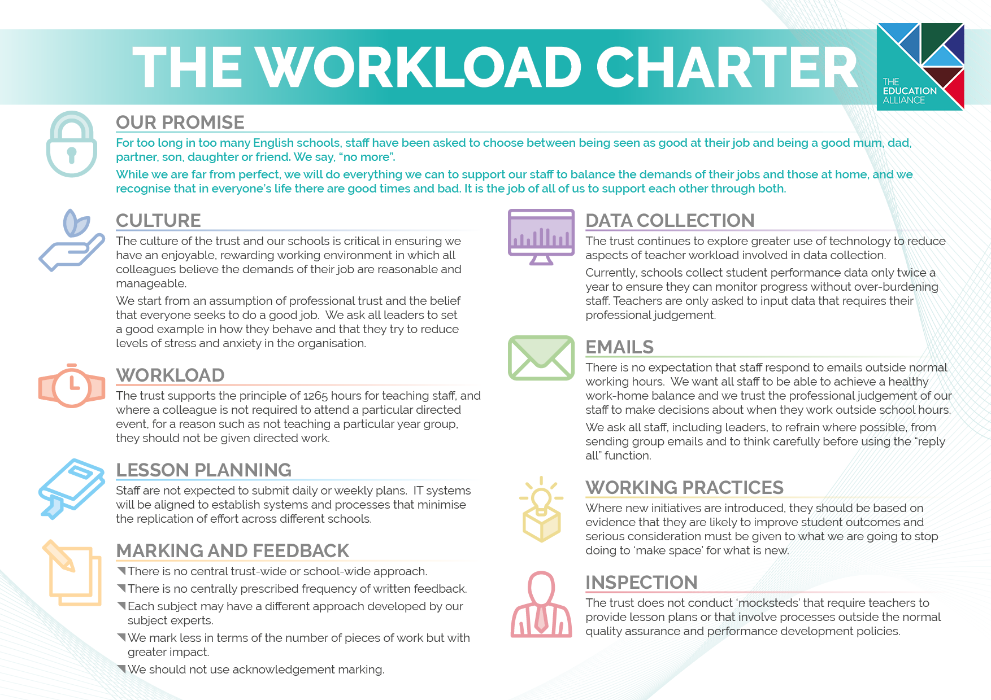
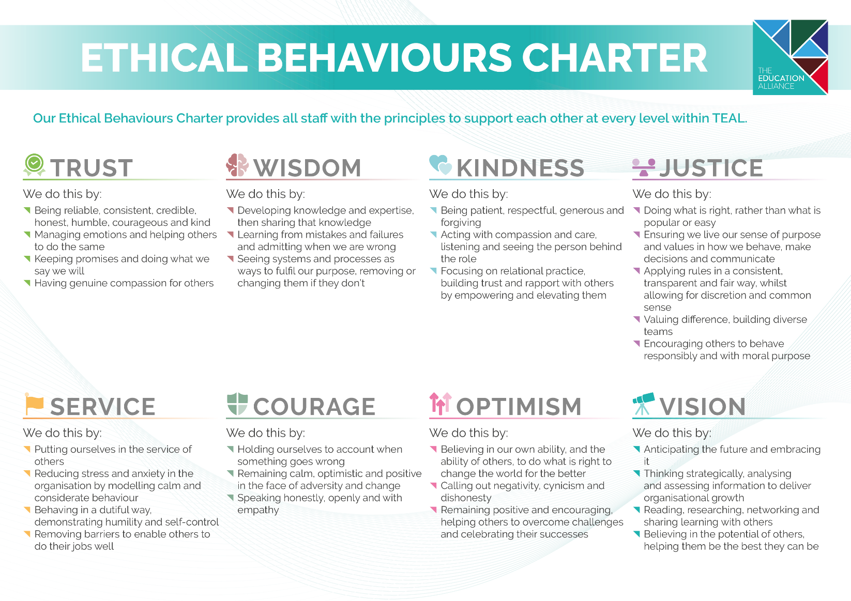

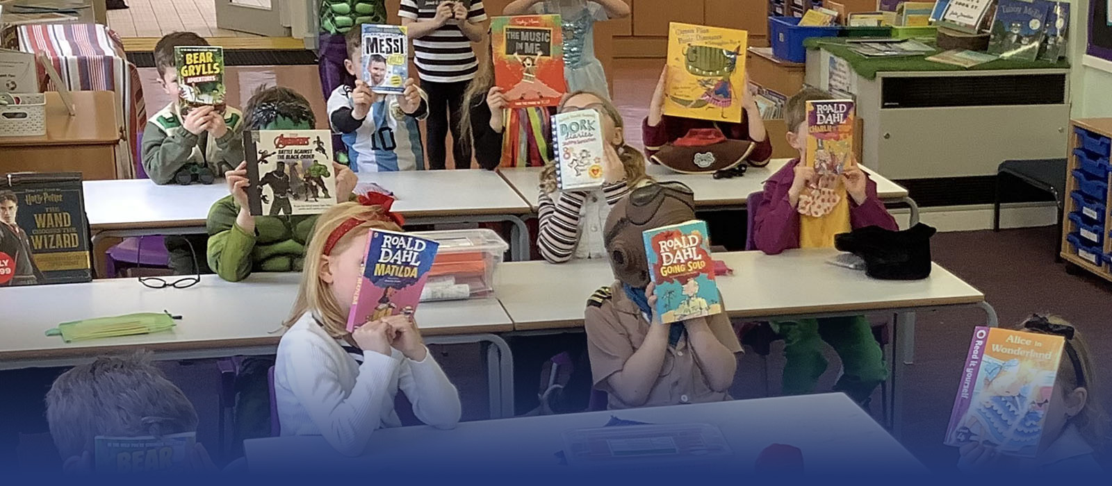

About Howden C of E Infant School
Our church school is home to a caring community of learners with a fantastic staff team, dedicated governors, supportive parents, strong links to Howden Minster and - most importantly - happy children.
At Howden C of E Infant school, we dedicate ourselves to serving the children and families in the town of Howden and its surrounding villages as we strive to realise our school vision – ‘Roots to grow so together we flourish’. Our strong, deeply embedded Christian values are at the root of everything we do here. For the children in our care to flourish, we firmly believe they need to be: known and valued as individuals; challenged academically; supported compassionately; and championed relentlessly.
It is our aim that all of our children develop curious minds and find joy in learning throughout their time with us. As such, they learn through a clearly sequenced, ambitious curriculum which is built upon guiding questions and enriched through visits, visitors and experiences. Children are involved in developing learning journeys and their interests are followed throughout.
We have three simple rules, which make up the Howden 3Ls and guide us through each day. These ensure that our children feel safe and happy at school:
- Learn well together (linked to our Christian values of curiosity and joy)
- Live well together (linked to our Christian value of respect)
- Look after one another (linked to our Christian values of family and nurture)

“Pupils are happy and confident. They enjoy coming to school.”
Ofsted 2019


Diocese of York
Leaders and staff work with York Diocese to develop a shared understanding of Spirituality and how this can be woven into the school’s provision.
York Diocesan Board of Education supports 123 Church of England schools and academies in the area from the Humber to the Tees. We have a dedicated team of professionals who offer a wide range of expertise and can help schools access further assistance.

The Education team aims to:
- Be available as a ‘one-stop shop’ for pastoral and professional support;
- Work with a range of agencies to promote school improvement;
- Promote excellence and Christian distinctiveness;
- Provide and facilitate professional development and governor training;
- Help schools and academies network, collaborate together and share best practice;
- Offer a Total Property Management scheme in association with DBE Services Ltd;
- Guide schools on matters concerning trusts;
- Work with schools exploring Academy conversion;
- Involvement in recruitment processes for new Headteachers/Heads of School;
- Support Headteacher appraisal;
- Represent Church of England education to the wider church community and more widely to the public;
- Maintain contact with the local authorities and the Regional Directors at the DfE.

The Rt Revd Barry Hill, Bishop of Whitby and Chair of the Diocesan Board of Education
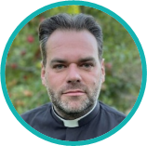
“Supporting children and young people to be all they are called to be is at the heart of who we are as the Diocese of York.
Together with the Church of England as a whole, it is a vision for education which is deeply Christian, with Jesus' promise of 'life in all its fullness' at its heart, and as such is for the common good of the whole community. It is a holistic vision, where education, like the faith in which it is rooted, is about wisdom, knowledge and skills, but also about hope and aspiration, about how we live well together in community with dignity and respect for all.
Of course a vision this encompassing is only possible by working in partnership, both between teachers, staff, trusts and governors, and in developing ever closer links between schools, churches and households. By working closely together we can achieve far more than apart. I am delighted that you are considering applying to be a Headteacher in the Diocese and know that, if appointed, you will join the diocesan family of schools dedicated to supporting you as you lead deeper into this vision so that together all our schools and communities can be places where the love of God is reflected through all we are.”

Mari Palmer, Diocesan Director of Education

“As a diocese, we are here to help celebrate and strengthen the Christian ethos in our schools. We understand that each school is unique and our aim is to get to know our schools on an individual basis in order to foster the local parish and community links as far as possible.
As such, our Education Team offers a range of support to our headteachers from both a school distinctiveness and effectiveness point of view, as well as providing a range of training and development opportunities for staff and governors to access over the course of each year. In a rapidly changing educational landscape, we are more and more involved in wider school development, particularly as schools change from one school status to another.
I do hope that you feel able to apply for the position and we would look forward to welcoming you as part of our diocesan family here in the Diocese of York.”

About the role and School Improvement
The success of our schools going forward depends on our ability to:
- Ensure we have a good teacher in every classroom
- Deliver an ambitious, inclusive curriculum
- Create a culture of wider personal excellence.
We build these upon effective systems for behaviour, safeguarding and care.
The successful candidate will oversee the running of Howden Infant School - on a daily basis - providing both strategic and operational leadership, supported by the Director of Primary Education (DPE) and Deputy CEO (Schools). The school is located next to Howden Junior School, enabling the successful candidate to work closely between the two leadership teams to share quality practice, plan transition, and support one another, alongside the support provided by the central team.
We have a highly effective Local Governing Body who provide both support and challenge to the leadership team in equal measure and ensure that the school remains at the heart of the local community.
The primary school improvement arm has grown over the last 18 months and means that each school now benefits from the following:
- Review meetings twice annually with the DPE, looking at how the trust can support each school with its improvement priorities.
- Regular 1:1 meetings with the DPE to support with current challenges and celebrate achievements.
- Collaboration with other primary schools in the trust, including a shared calendar of joint work (including moderation and sharing of resources).
- Primary Subject Leaders (PSLs) who have dedicated time to work with TEAL’s primary schools (including planning and collaboration on shared approaches, but also direct school-to-school support where it is needed).
Currently, PSLs lead on the following areas:
  - EYFS
  - English
  - Maths
  - Curriculum and Pedagogy
  - SEND
  - Enrichment and Engagement
  - Access to our Safeguarding Team for support, guidance and supervision for DSLs.
  - An independent School Improvement Partner (SIP), contracted from another local trust.
We also work closely with the Diocese of York, ensuring academic spiritual and personal development for all our children, providing rich and exciting first-hand experiences both in the classroom and through other enriching activities.

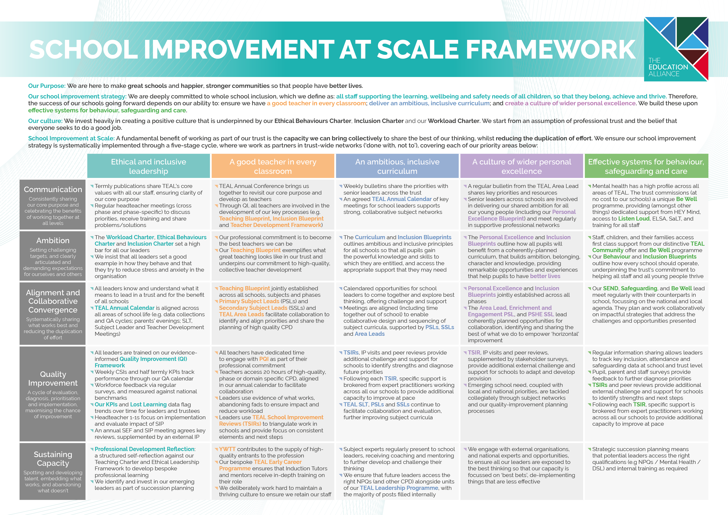


Be Well

The Be Well programme is a unique resource commissioned by The Education Alliance, to increase mental health provision for children, staff and parents across schools in our Trust. The programme is made possible through close partnerships with several organisations and is made possible with the support of Pagabo.
The Be Well Programme consists of three elements:

- Mind – The Whole School Approach for all children, parents and staff
- Listen LOUD – Let’s Open Up Discussions, providing a young person the opportunities to build confidence, develop communication skills and celebrate individual achievement

- ELSA – Emotional literacy support for primary aged children
TEAL invests £250,000 a year from its TEAL Social Value company to provide the following to schools:
- Funding for HEY Mind to provide dedicated time for a Mind professional to work within our primary and secondary schools to implement a range of interventions and training from their menu. This includes: a drop in facility for pupils and staff; support and training for staff (e.g. Youth Mental Health First Aiders and how to have a conversation about mental health); pupil resilience intervention training; pupil Well-Being Ambassador training, and more intensive support through the Big Umbrella programme.

- A commitment to training Youth Mental Health First Aiders at a ratio of 50:1 within our schools.
- A listening service for pupils, parents/carers and staff (as a drop-in service, in person or virtually).
- A high-quality training programme for young people who wish to become Well-Being Ambassadors.
- In our primary schools, additional ELSA staffing to increase mental health and wellbeing support for pupils, parents/carers and our staff in a responsive and proactive way.

The TEAL Family of Schools
7,241 children on roll across 12 schools
1,114 members of Team TEAL

TEAL Central Team
TEAL schools also benefit from expert support and guidance, delivered by experienced professionals within the TEAL Central Team. This includes school support (encompassing compliance, data management, estates - including health and safety - finance, governance, HR, IT and payroll).
The successful applicant for this post will join the TEAL Central Team as part of our TEAL School Improvement Team. Led by the Deputy CEO, this team focus on supporting schools in driving their improvement priorities, with the view that we support Senior Leaders in school by doing the ‘heavy lifting’ and aiding their development.
In addition to the advertised post and Deputy CEO, The TEAL School Improvement Team consists of:
- Director of Primary Education
- Director of Inclusion
- Vice Principal for Subject Development and Standards
- Vice Principal for Teacher Development
- Vice Principal for Curriculum
- Assistant Principal for CPD and Literacy

The School Improvement Team’s priorities are led by the shared priorities of our schools, with them working closely with leaders across our schools to improve the experiences of our pupils, staff and the communities that we serve.
“I have thoroughly enjoyed my time as part of the TEAL School Improvement Team since joining it in 2023. I especially relish the opportunity to be able to support our colleagues at scale and – through this – make a real difference for the pupils and communities we serve.

As well as benefiting from the expertise of my colleagues in the TEAL Central Team, I feel lucky to be able to also be part of a school leadership team. This helps me consider which strategic decisions will have the most impact on our schools’ improvement journeys. Moreover, I really appreciate the varied nature of our roles in the TEAL Central Team, which means that I feel constantly challenged and continually improve myself as a leader and educator.”
– Richard McDonald, Assistant Principal for CPD and Literacy

What do TEAL headteachers say?

Being new to headship, the amount of support, reassurance, and encouragement I have been given in my first year has been fantastic. This support is readily available from the wider trust team and our team of headteachers whenever I need advice. Being part of a group of schools means that you are never alone; there is always someone on hand to offer guidance. There is a vast amount of collaboration, creativity and sharing of ideas and resources. There are absolutely no egos, or competition: everyone works together with the ultimate aim of increasing life chances for our pupils (and by our pupils, I mean TEAL pupils). The expertise shared across TEAL takes place at all levels, making everyone’s lives easier, reducing the duplication of effort and therefore lessening the workload of everyone. At the same time, this expertise ensures that everyone can further develop and become better at what they do, whatever their role in school. I can honestly say I would not be a headteacher anywhere else other than TEAL.
Heather Yates

Our school joined The Education Alliance in November 2019 and since then we have benefited immensely from working within the Trust. The support has been invaluable on many different levels. Our staff really appreciate working collaboratively with other colleagues within TEAL to develop our curriculum and share training. We have also really valued the support we have received in other areas, such as finance, HR, catering, and premises. We are excited to be part of TEAL as we continue to enhance the opportunities for our children.
Richard Winks

Some say that headship can be a ‘lonely place’, at times. Not in The Education Alliance! Malet Lambert was lucky to be one of the first schools to join TEAL. The support we receive as a school from the central team has been crucial in our development. Much of the ‘heavy lifting’ is taken away from schools, which means my leadership team and I can focus more on the day-to-day running of the school, whilst working alongside trust colleagues strategically. The trust has assisted us in the development of the school, whether it be our curriculum offer, value for money procurement or sustainability. The skillset in the trust team is strong and varied. The size of the trust also allows a very personal offer, where everyone knows everyone else and you very much feel like a valued school, rather than just a number. Malet Lambert is a very proud member of TEAL, as am I as a headteacher.
Patrick Sprakes

South Hunsley School was the founding school of TEAL and from those early days, the trust has grown in size and reputation. Leading ethically, collaborating at all levels, committing to professional development and reducing workload are just a few of the reasons why I chose to apply for a second headship within the trust. Despite some of the challenges we face in schools, I enjoy my job enormously. What can be more rewarding than seeing young people happy and successful? The accountability is high, but we work in a culture of low threat and professional trust, resulting in me feeling highly motivated, challenged and supported to do the best job I can for the benefit of the staff, young people and wider community that we serve.
Michaela Blackledge

As headteacher of Hunsley Primary, I have always felt the strength of collaboration and shared moral purpose across the trust's schools to be a powerful support in all aspects of my role. Schools and their leaders will always face both opportunities and challenges - often in equal measure - and it is inspiring to know that no leader in the trust works alone. Instead, we work positively and creatively across a wide team to share one another's successes and to offer thoughtful solutions to questions, inspired by the same values. As a group of headteachers, our collective understanding and experience mean that we draw on each other readily, in a proper spirit of support and mutual respect.
Lucy Hudson

As a new headteacher, being part of TEAL is invaluable. I am part of a wider team of headteachers who I am able to share ideas with, seek advice from and, ultimately, this helps to improve the experiences for all our young people. The advantage of working as a group of schools is that we can share ideas and resources which reduce workload and make people’s lives easier. This reduces the duplication of effort across TEAL and helps us take full advantage of the expertise we have in all of our schools. A wide range of similar groups work together regularly, including whole-school curriculum leaders, pastoral leaders and SENDCos. Whatever your role in TEAL, the opportunity to work with other people across our schools helps us to secure the best experience for our pupils, whilst keeping workload as manageable as possible.
Vicky Loftus

Since joining the Education Alliance in December 2023, I can confidently say it has made our school, and the communities it serves, a much better experience for staff, pupils and their families. We chose to join TEAL as their values around ethical leadership, ‘doing the right thing’ and servant leadership aligned with ours. They have now become lived experiences for us and the support for me as Executive Headteacher and the staff team across the school is significantly positive. Senior leaders have fantastic opportunities to collaborate, work strategically and share experiences. The value TEAL places on people, their wellbeing and happiness is a constant thread, woven into everyday working life. This, alongside the young people we work with, is always the ‘driver’ of decisions and changes. As a leader, I feel the opportunity to reach out for advice or support is the most powerful resource TEAL have offered. This allows me to focus on the things that will make the biggest difference to the school and the pupils in it.
Paul Grimes

We joined TEAL in May 2024 and have continued to receive excellent support and positivity. As a headteacher, it is very difficult to keep plates spinning, and to know that there is always someone there to help when you need it can be all you need. The services TEAL offer are extremely professional and a vital support with the very difficult 'heavy lifting' that is inevitable in such a diverse role. The range of people that we can seek support from, combined with the depth of knowledge and experience behind that, means that I can prioritise the most important aspects of my role. There is a definite purpose and clear mission enacted by TEAL; as headteachers, we work closely together to improve outcomes for children and the communities we serve. Having recently exited the maintained system (where it can be difficult to work so closely together with other schools), I can see how powerful this united approach will be in fulfilling our core purpose. I am looking forward to seeing how our journey progresses.
Luke Fletcher
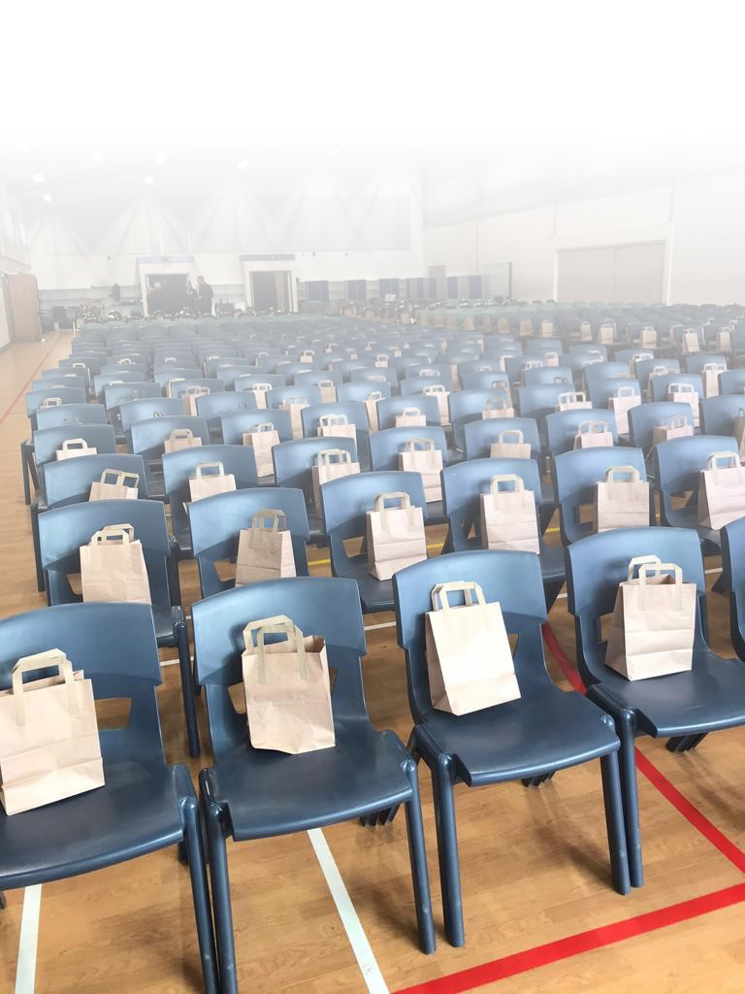

What do our staff say about TEAL?
We regularly gather staff voice, including considering workload and well-being. This includes annual review against the questions used by the TES Wellbeing Report.
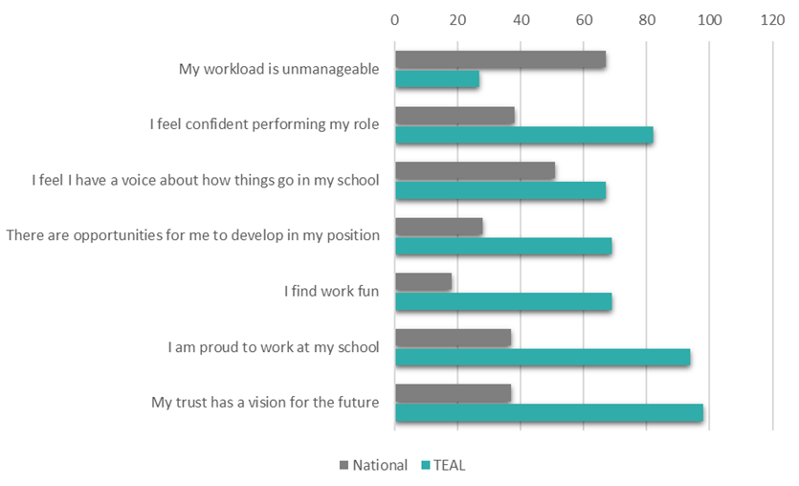
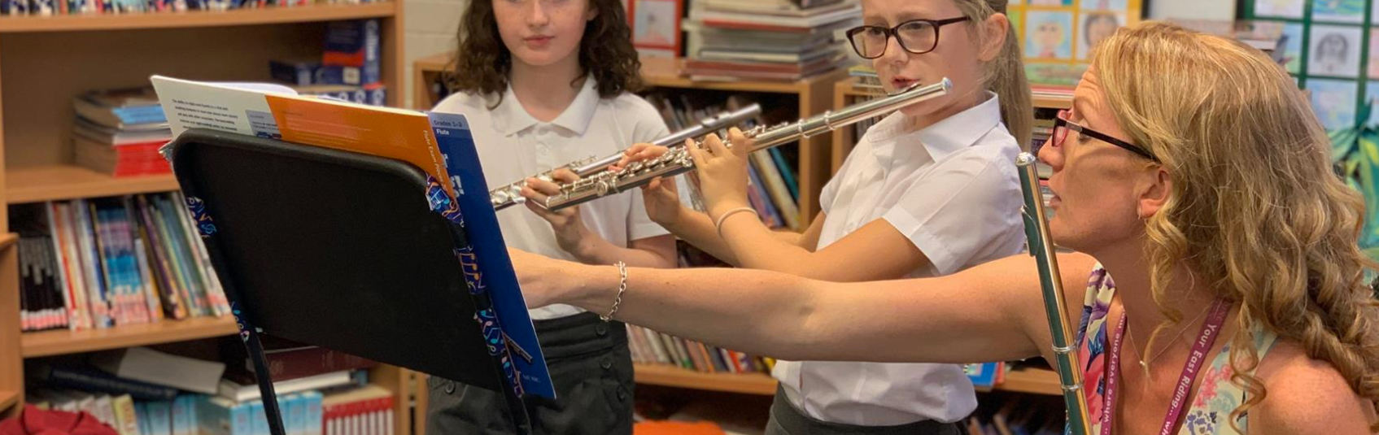

“My role allows me to work across TEAL, supporting all of our schools alongside collaborating on projects with a variety of stakeholders. Projects can start from the due diligence stage and it is great to have the opportunity to work with incoming schools from an early stage. No two days are the same and I continue to learn and gain experience from every new school that joins the TEAL family.”
Francesca Roper, Director of Trust Development and Compliance


The Local Area
Howden is a bustling market town located in the East Riding of Yorkshire. Lying in the Vale of York to the north of the M62, it is well known for Howden Minster, one of the largest churches in the East Riding; we are very fortunate that our pupils are able to take part in a range of activities held here.
The town was given by William the Conqueror to the Bishops of Durham in 1080 and has a deep historical connection with the royal family to this day. The town had a population of just under 20,000 at the last census and has grown extensively since then. With further housebuilding earmarked to take place well into 2030, it is envisaged that there will be the requirement for further school places to be made available.
Hull and the East Riding of Yorkshire have benefited from billions of pounds of private sector investment across multiple industries. The region offers lower than average house prices, a fantastic choice of schools and areas of unrivalled natural beauty. The region has so much to offer in terms of landscape and heritage. With lots of thriving market towns, shopping and eating out options are endless and with the beautiful countryside of the Lincolnshire and Yorkshire Wolds making up a huge proportion of the area, there is no shortage of areas for walking, riding, cycling and running.
Here at TEAL, we recognise that deciding to relocate can be a big decision for the whole family. To help and support with such a big change, we offer a generous relocation assistance package; further details can be found on our website: Relocation Assistance Policy.pdf

The Recruitment Process
We are proud of our schools and welcome the opportunity to show any prospective candidates around our sites. We are also happy to arrange an informal chat with our DPE if this would be of benefit to candidates. If you would like to visit the school, this can be arranged for Friday 14th November at 2:15pm or Monday 17th November at 9:15am. Please email recruitment@theeducationalliance.org.uk to arrange a visit.

The closing date for applications is Wednesday 24th November 2025 at 9am, with shortlisting taking place later that week. We envisage that successful candidates will be invited to first stage interviews on 1st December 2025. Second stage interviews will be arranged subsequently. Interviews will involve a variety of tasks with key stakeholders from TEAL and the Diocese of York.

For more information about the schools and everything we have to offer, please visit https://howdeninfants.net/, and https://theeducationalliance.org.uk/.

Job Description
(Headteacher)
Reporting To: (Director of Primary Education)
Job Purpose
- To balance the strategic and operational leadership of their school and assume overarching responsibility for all aspects of functionality, management, performance and improvement. The post holder will oversee the school leadership team in raising standards, both academic and pastoral, to ensure the school build a reputation for excellence. With a passion for improving the life chances of young people, the post holder will engage with pupils, staff, parents and carers in an insightful, professional, skilful way, developing positive relationships, and reflecting all aspects of our ethical leadership competencies in everything they do.

Key Responsibilities: Specific
Strategic Leadership and School Development
- Develop the strategic vision and direction for the school in partnership with TEAL SLT, the Local Governing Body (LGB), and all stakeholders, ensuring alignment and leadership of the Christian values and ethos of the Infant school.
- Develop and maintain an ethos which enables secure and effective teaching and progress for all pupils, irrespective of their background, abilities or aptitudes.
- Provide leadership that enables the school to deliver ongoing improvement in line with ambitious targets and their own improvement priorities.
- Support the CEO and TEAL SLT to establish and sustain the trust’s values, culture, and strategic direction in partnership with the Trust Board.
- Participate in performance development in accordance with school policy and understand how this fits with CPD.
Quality of Education
- Ensure all pupils benefit from an expertly designed and well sequenced curriculum so that pupils are exposed to the knowledge and skills they need for the future, and reflects the Infant school’s Christian ethos
- Ensure that teaching and learning throughout the school are of the highest standards so that all pupils achieve well, including those with SEND.
- Tackle educational inequality, upholding and securing ambitious educational and behavioural standards for all pupils.
- Promote further support for the most disadvantaged and those with additional and special educational needs and disabilities within a safe and secure environment.
- Monitor the effectiveness of the quality of all aspects of provision, continually seeking areas for improvement and celebrating success
Resources
- Deploy resources effectively and efficiently in order to achieve the aims and objectives as set out in the School Improvement Plan.
- Effectively recruit and manage the staff of the school, utilising curriculum led financial planning and following all aspects of safer recruitment.
- Plan and monitor the school’s budget, carefully monitoring pupil numbers and anticipating challenges ahead.
- Ensure that current estate and working environment is maintained and improved for the benefit of the pupils and school community.
Accountability and Governance
- Be accountable for the strategic leadership and management of the school, ensuring continuing improvement.
- Ensure that all staff are aware of, and operate within, TEAL Blueprints and Charters, upholding the strategic and ethical principles of the trust, promoting a culture of accountability that is recognised and accepted as an essential element of improvement at all levels and across all aspects of the trust’s work.
- Understand and welcome the role of effective trust governance, upholding the obligation to give account and recognising that Trust Boards are ultimately responsible and accountable for the trust’s work.
- Ensure the LGB, Executive Team, Education Committee and Trust Board receive quality information, providing information which enables them to fully meet their responsibilities
System Leadership and Civic Responsibility
- Provide leadership which will inspire, motivate, challenge and support all staff employed by the school.
- Lead by example, with integrity, care and compassion, creativity, resilience and clarity, drawing on their knowledge, skill and expertise, and that of those around them.
- Work collaboratively with other Headteachers to identify areas for improvement, identifying opportunities to align our work where appropriate, to share what is best in all our schools, reducing the duplication of effort.
- Sustain wide, current knowledge and understanding of education and school systems locally, nationally and globally, working with political and financial astuteness, within a clear set of principles centred on the trust’s vision and ethos, translating strategic thinking into operational delivery.
Religious Education (RE) and Collective Worship
- Oversee the provision and delivery of Religious Education (RE) at the Infant school, ensuring that the subject reflects the Christian ethos of the school and is engaging and appropriate for the age group.
- Ensure that Collective Worship is meaningful, inclusive, and aligns with the Christian faith, creating opportunities for pupils to reflect spiritually and morally.
- Develop links with the local church community, ensuring a strong partnership in the faith development of pupils.

Key Responsibilities: General
- The responsibilities outlined are a broad indication of the main duties and responsibilities of the post and employees will be expected to comply with any reasonable request from a manager to undertake work of a similar level that is not specified in this job description.
- TEAL is committed to safeguarding and promoting the welfare of children, young people and vulnerable adults and expects all employees and volunteers to share this commitment.
- TEAL/The school will endeavour to make any necessary reasonable adjustments to the job and the working environment to enable access to employment opportunities for disabled job applicants or continued employment for any employee who develops a disabling condition.
- The Health and Safety at Work etc. Act, 1974 and other associated legislation places responsibilities for Health and Safety on all employees. Therefore, it is the postholder’s responsibility to take reasonable care for Health and Safety and Welfare of him/herself and other employees in accordance with legislation.
- The above duties may involve having access to information of a confidential nature, which may be covered by GDPR, and by Part 1 of Schedule 12A to the Local Government Act, 1972. Confidentiality must be maintained at all times.
- The postholder must work and process personal and sensitive information in accordance with Data Protection Act 2018 including the General Data Protection Regulations (GDPR) 2018 and to ensure work is conducted in a way that protects the safety and security of information (e.g. strong passwords, reporting breaches, securing paper records, securely disposing of records).

Person Specification
Headteacher
Criteria |  | Evidence | Scoring Method
Qualifications and Experience | Honours degree in relevant specialism | A | Pass/Fail
Qualifications and Experience | Has QTS (before start date) | A | Pass/Fail
Qualifications and Experience | Leadership/management qualification i.e. Senior Leadership NPQ (Desirable) | A | Numerical Scale
Qualifications and Experience | Experience of delivering CPD including coaching and mentoring colleagues. | A/I | Numerical Scale
Qualifications and Experience | Experience of leading curriculum development across all primary phases | A/I | Numerical Scale
Qualifications and Experience | Extensive experience working at Senior Leadership Level | A/I | Numerical Scale
Qualifications and Experience | Recent experience working as a School Headteacher (Desirable) | A
Qualifications and Experience | Previous experience working in a school with a Christian ethos (Desirable) | A/I | Numerical Scale
Qualifications and Experience | Experience of SIAMs inspections (Desirable) | A/I | Numerical scale
Knowledge and Skills | Proven track record in implementing strategies and interventions to raise achievement and standards, narrowing gaps in attainment and progression | A/I | Numerical scale
Knowledge and Skills | Demonstrates effective communication skills (both orally and in writing), relevant to the audience and purpose. | A/I | Numerical scale
Knowledge and Skills | Extensive knowledge of the principles and practices of effective teaching and learning, monitoring/ assessment and evaluation. | A/I | Numerical scale
Knowledge and Skills | Demonstrable knowledge of quality improvement and effectiveness strategies including the process of self-evaluation and strategies for raising quality standards | A/I | Numerical scale
Knowledge and Skills | Has well-developed ICT skills including a good working knowledge of Microsoft 365 Applications i.e. Word, Excell, Outlook, Teams etc with the ability to utilise ICT to enhance teaching and learning and to collate, interrogate and interpret data. | A/I | Numerical scale
Knowledge and Skills | Demonstrates effective financial planning and budget management skills | I | Numerical scale
Values and Behaviours | Makes a commitment to their own professional development in order to become the best leader they can be. | I | Numerical scale
Values and Behaviours | Demonstrates an ability to build and maintain positive relationships with pupils, colleagues, parents and carers, with a positive outlook and a sense of humour | I | Numerical scale
Values and Behaviours | Makes a commitment to ensuring their values and behaviours align with TEAL’s Ethical Leadership qualities as outlined in the values and behaviour’s framework (see Job Description), as commensurate with their role | I | Numerical scale

A = Application (inc. supporting letter) I = assessed during Interview Day(s)
TEAL is committed to safeguarding and promoting the safety and welfare of children and young people and expects all staff to share the commitment. All appointments will, therefore, be subject to a satisfactory Enhanced Level Disclosure and Barring Service Clearance as well as all other relevant pre-employment vetting checks.


The Education Alliance
East Dale Road
Melton
North Ferriby
HU14 3HS


01482 636720


theeducationalliance.org.uk

