

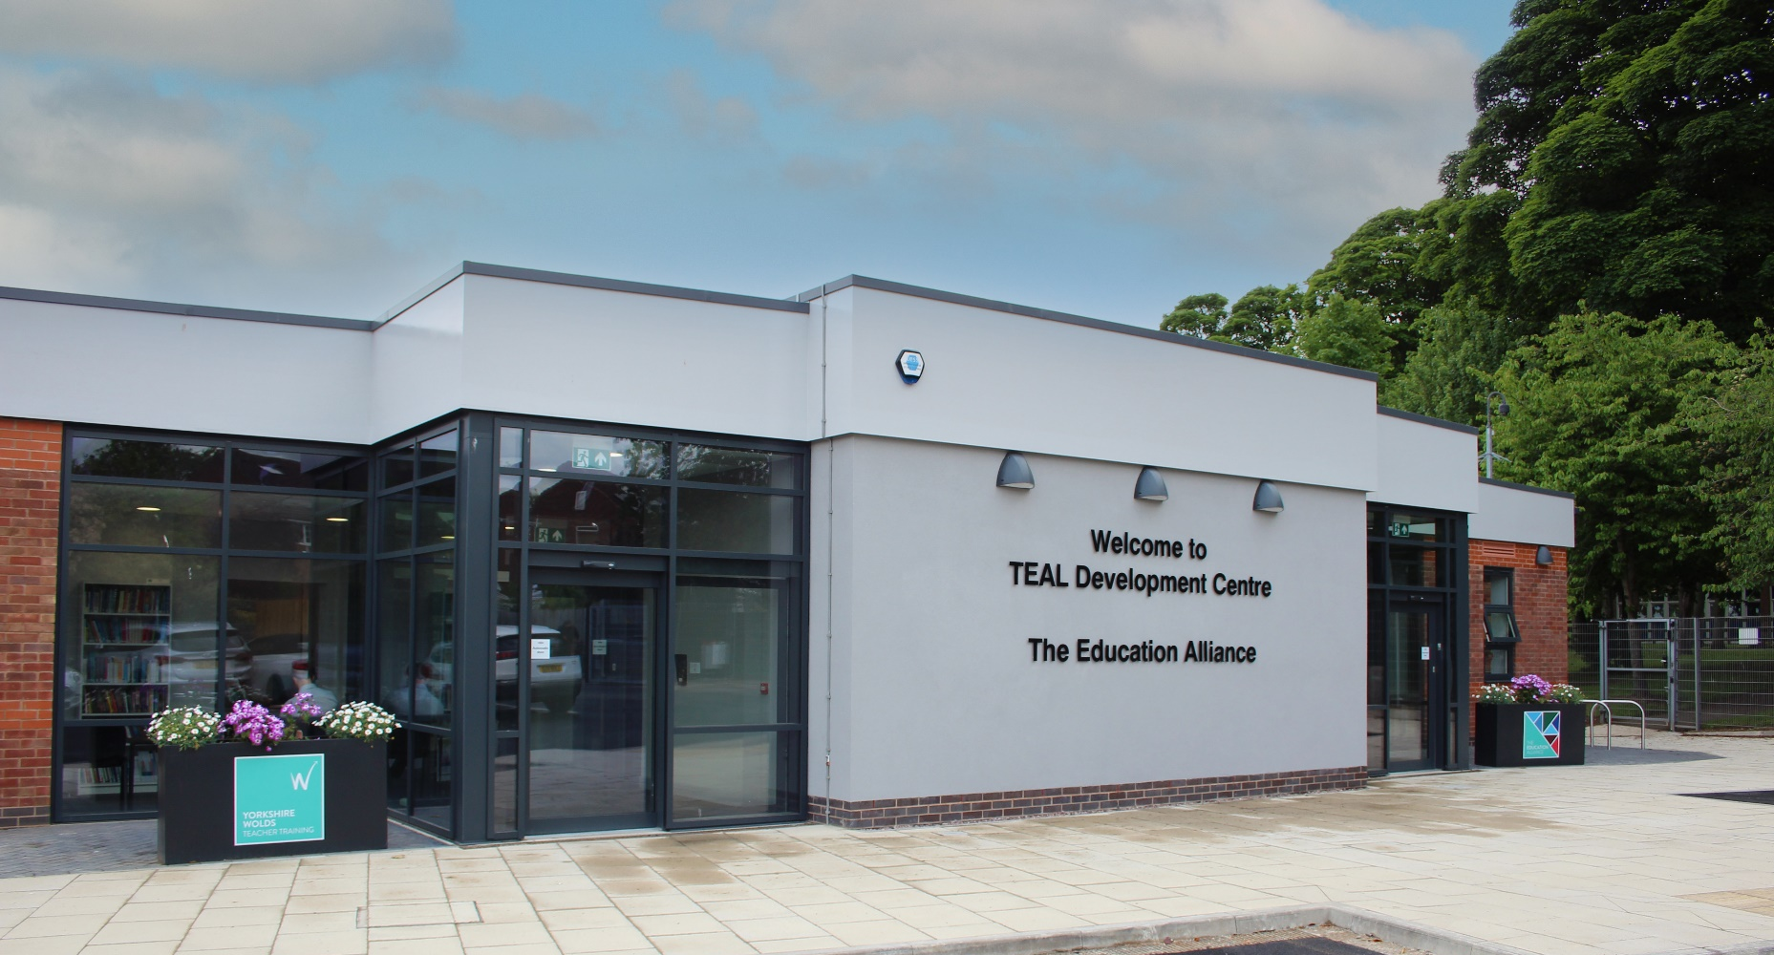
Assistant Principal - Primary
Applicant Pack
Contents
Welcome letter from Jonny Uttley CEO 4
About The Education Alliance 5
Our promise 6
Welcome from Kris Henderson, 7
Director of Primary Education 7
Where We Are 8
Be Well 13
TEAL Central Team 14
What do TEAL Headteachers Say? 15
What do our staff say about TEAL? 18
What does Ofsted say about TEAL? 19
Our Estates 20
The Recruitment Process 21
Job Description 22
Person Specification 24


“We are here to make great schools and happier, stronger communities so that people have better lives.”


Welcome letter from Jonny Uttley CEO
I would like to welcome you to the Education Alliance; let me tell you a little bit about us.
Our core purpose is to make great schools and happier, stronger communities so that people have better lives. This underpins everything we do. The way we do this is by: always doing what is right; standing shoulder-to-shoulder; and focussing on quality in everything we do.
Within TEAL, we advance high-quality inclusive education that values all young people equally. We achieve this by ensuring all schools in the TEAL family are successful and all our young people thrive, as well as developing the next generation of great teachers and leaders. Moreover, TEAL connects with civic leaders, influencing the system so that it becomes more equitable, inclusive, sustainable and ethical.
Included here are our Workload Charter and Ethical Behaviours Charter, which will give you a sense of how this vision and purpose is reflected in our approach.
We look forward to hearing from you.
Jonny Uttley
CEO, The Education Alliance



About The Education Alliance
The Education Alliance Multi-Academy Trust was established in 2015 so that South Hunsley School and Sixth Form College could support the setting up of Hunsley Primary School, the East Riding’s first Free School. Since then, a further ten schools in the region have joined:
2015
} South Hunsley School and Sixth Form College
} Hunsley Primary
February 2016
Malet Lambert |
February 2017
} Driffield School and Sixth Form
April 2019
The Snaith School |
November 2019
} North Cave CE Primary School
October 2022
Howden Junior School |
May 2023
} Wilberfoss CE Primary School
September 2023
Howden CE Infant School |
October 2023
} Naburn CE Primary School
December 2023
The Hub School |
May 2024
} Beverley Minster CE Primary School

In addition to the twelve schools, the trust also operates Yorkshire Wolds Teacher Training, the only Outstanding SCITT based in East Yorkshire, which is training a new generation of primary and secondary teachers in East Riding and Hull.




Our promise
We recognise that the commitment and care of all staff are fundamental to our pupils’ success; therefore, we promise our staff that they will be supported, encouraged, respected and provided with an enjoyable and rewarding working environment.

The Education Alliance is dedicated to developing, growing and retaining talented leaders and staff across the trust, with staff development a critical element of this. We want our schools to be places where people want to work and choose to stay. For too long, in too many English schools, staff have been asked to choose between being seen as good at their job and being a good mum, dad, partner, son, daughter or friend. We say: “no more”.

While we are far from perfect, we will do everything we can to support our staff to balance the demands of their jobs and those at home, recognising there are good times and bad in everyone’s life. It is our job to support each other through both. In turn, all our schools will have a deep commitment to the entire school system, adding value through collaboration and ensuring that our decisions do not impact negatively on other schools (locally or nationally).

We invest heavily in creating a positive culture that is underpinned by our Ethical Behaviours Charter (centred around Trust, Optimism, Kindness, Courage, Service, Wisdom, Justice and Vision) and our Workload Charter. The culture of the trust and our schools is critical in ensuring we have an enjoyable, rewarding working environment in which all colleagues believe the demands of their job are reasonable and manageable.

It is essential that our schools are led in an ethical way that is driven by moral purpose. Many of the difficulties that staff experience in schools come from a high stakes accountability system that can drive leaders to behave in ways that increase stress and anxiety for staff. At TEAL, however, we start from an assumption of professional trust and the belief that everyone seeks to do a good job. We insist that our leaders do everything they can to guard against this, setting a good example in how they behave and trying to reduce levels of stress and anxiety in the organisation. To support this, we offer training and development for our managers and leaders to ensure they are able to translate the vision and values into day-to-day practices and behaviours.

Recruitment and retention in schools is becoming increasingly challenging. Evidence shows that workload is cited as the main reason teachers leave the profession. Workload can include various aspects of teachers’ working lives (including marking, planning, preparation, monitoring, evaluation and data collection). TEAL recognises its duty of care towards its staff and is committed to working with its recognised trade unions to clarify workload expectations, supporting staff to achieve a healthy work-home balance. This commitment is genuine and sincere, applying to everyone in the trust. Leaders are expected to demonstrate this commitment and to be mindful of what is reasonable for colleagues at all levels of the organisation.


Welcome from Kris Henderson,

Director of Primary Education

As a trust, we have established strong and purposeful collaboration across our primary schools. In my role as Director of Primary Education, I work closely with headteachers and Primary Subject Leads (PSLs) to support each school’s improvement aims and review self-evaluation, ensuring that priorities are clearly understood, strategically acted upon and regularly reviewed. Although our schools differ in size, age range and context, we harness the power of collective working wherever it adds value. This has been evident in the successful introduction of Little Wandle phonics across all primaries, enabling us to share expertise and reduce workload and in our recent work to embed Talk for Writing across the trust.
These shared approaches are strengthened by the expertise of our PSLs, who provide high-quality, specialist support across a wide range of curriculum areas. Their work ensures that each school receives tailored guidance aligned with its individual improvement priorities, while contributing to a trust-wide culture of consistency, high expectations and evidence-informed practice.
The creation of this new Assistant Principal for Primary role will build further capacity across the trust, enhancing our ability to drive school improvement with precision and pace. By providing additional leadership, strategic oversight and targeted support, this role will strengthen the coherence of our trust-wide initiatives, alongside enabling each school to continue growing its unique strengths in their pursuit of our overall ambition – to make great schools and happier, stronger communities so that people have better lives.



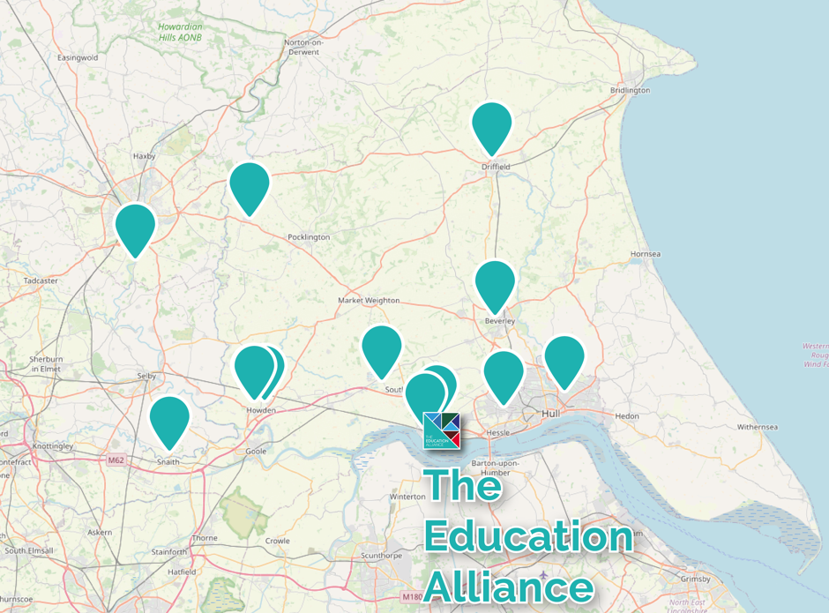
Where We Are

The Education Alliance is predominantly based in the East Riding of Yorkshire. Our twelve schools have a spread across the locality with Malet Lambert School, based in Hull, and Naburn CE Primary School, based in York. Being in such proximity to each other ensures that we can share expertise and resources effectively.
“I was attracted to the role as I knew it would give me the opportunity to work with a variety of colleagues across a diverse group of schools and develop my knowledge in the education sector. I love meeting and working with a variety of people and think this really helps build positive relations professionally but also personally. TEAL stands out to me from anywhere else I have worked, a few reasons being that I have a strong network around me with colleagues who are highly supportive and approachable, each day brings a new challenge and something different to the table, the working environment is always fun but professional when it needs to be, and most of all, I feel valued and appreciated as an employee.”
– Victoria Dent, Chief of Staff

“We believe that great schools start with a positive culture in which everyone feels valued and a strong sense of belonging.”

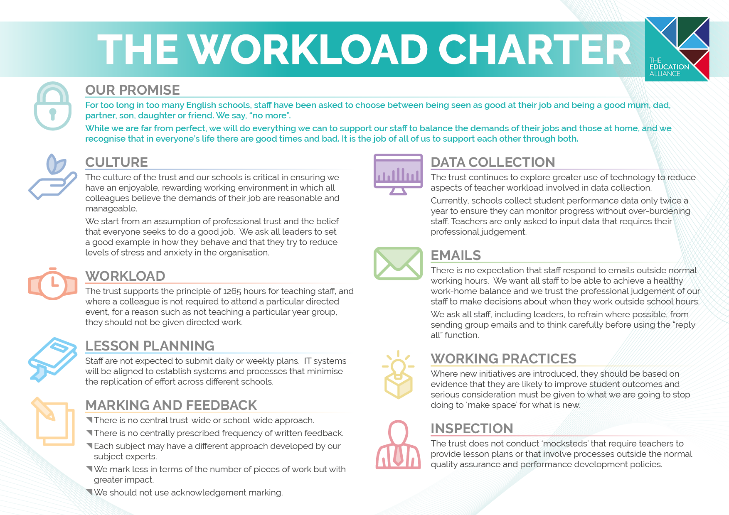
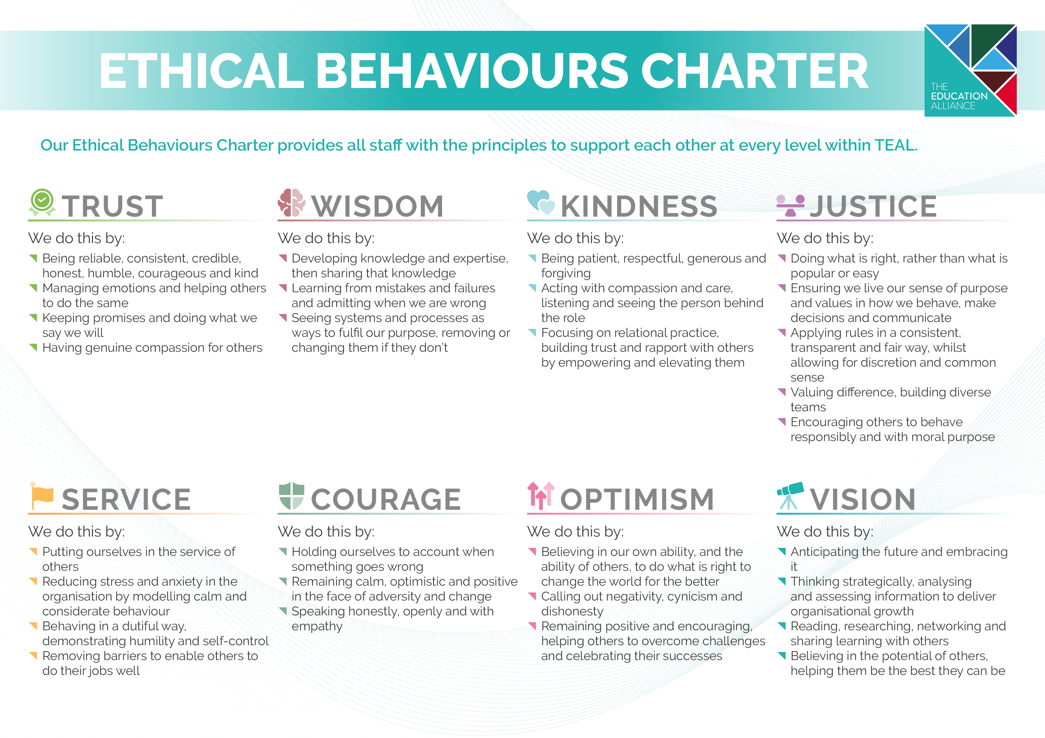
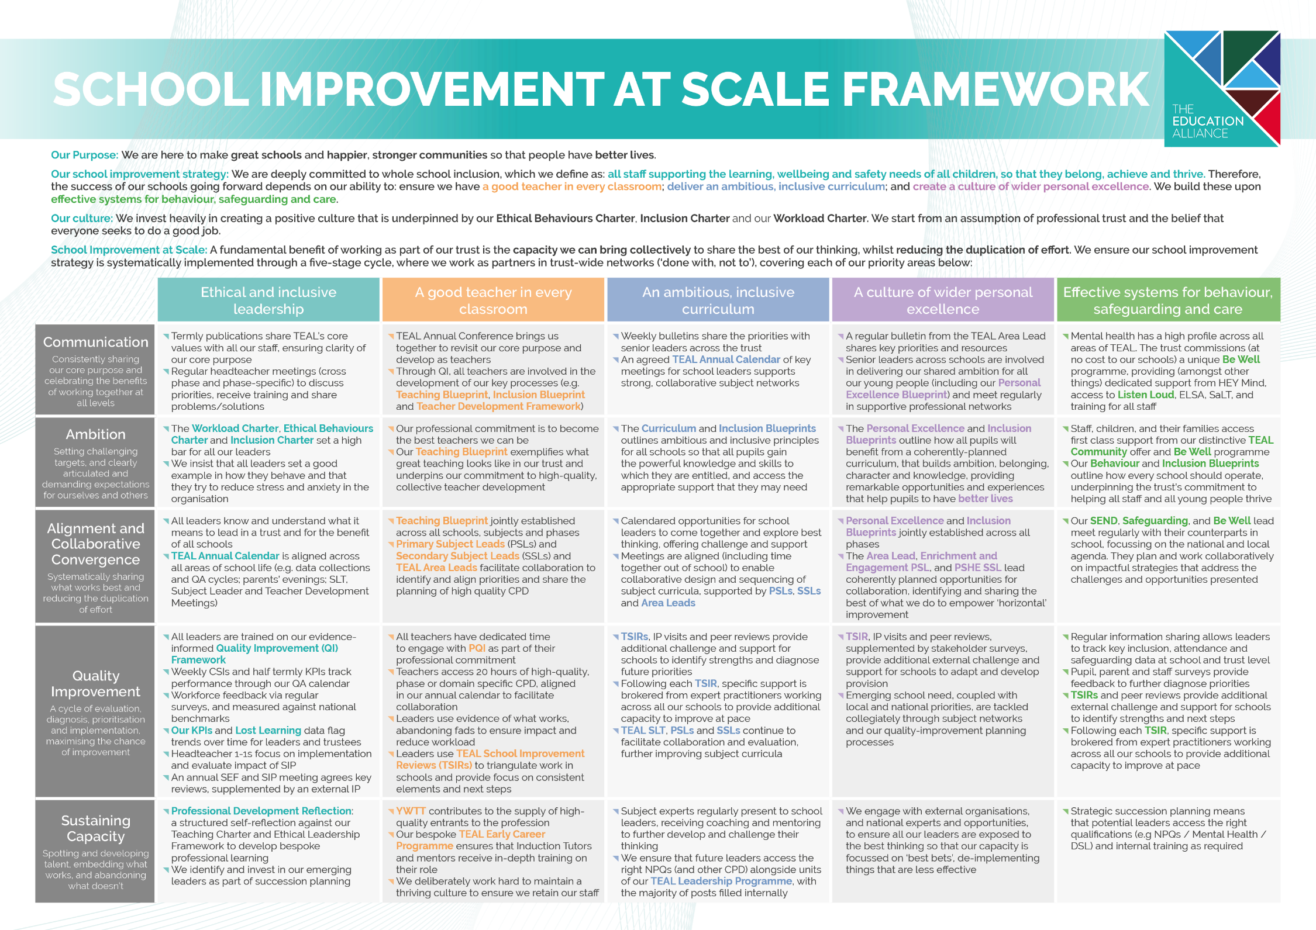


Be Well

The Be Well programme is a unique resource commissioned by The Education Alliance, to increase mental health provision for children, staff and parents across schools in our Trust. The programme is made possible through close partnerships with several organisations and is made possible with the support of Pagabo.
The Be Well Programme consists of three elements:

- Mind – The Whole School Approach for all children, parents and staff
- Listen LOUD – Let’s Open Up Discussions, providing a young person the opportunities to build confidence, develop communication skills and celebrate individual achievement

- ELSA – Emotional literacy support for primary aged children
TEAL invests £250,000 a year from its TEAL Social Value company to provide the following to schools:
- Funding for HEY Mind to provide dedicated time for a Mind professional to work within our primary and secondary schools to implement a range of interventions and training from their menu. This includes: a drop in facility for pupils and staff; support and training for staff (e.g. Youth Mental Health First Aiders and how to have a conversation about mental health); pupil resilience intervention training; pupil Well-Being Ambassador training, and more intensive support through the Big Umbrella programme.

- A commitment to training Youth Mental Health First Aiders at a ratio of 50:1 within our schools.
- A listening service for pupils, parents/carers and staff (as a drop-in service, in person or virtually).
- A high-quality training programme for young people who wish to become Well-Being Ambassadors.
- In our primary schools, additional ELSA staffing to increase mental health and wellbeing support for pupils, parents/carers and our staff in a responsive and proactive way.

The TEAL Family of Schools
7,241 children on roll across 12 schools
1,114 members of Team TEAL

TEAL Central Team
TEAL schools also benefit from expert support and guidance, delivered by experienced professionals within the TEAL Central Team. This includes school support (encompassing compliance, data management, estates - including health and safety - finance, governance, HR, IT and payroll).
The successful applicant for this post will join the TEAL Central Team as part of our TEAL School Improvement Team. Led by the Deputy CEO, this team focus on supporting schools in driving their improvement priorities, with the view that we support Senior Leaders in school by doing the ‘heavy lifting’ and aiding their development.
In addition to the advertised post and Deputy CEO, The TEAL School Improvement Team consists of:
- Director of Primary Education
- Director of Inclusion
- Vice Principal for Subject Development and Standards
- Vice Principal for Teacher Development
- Vice Principal for Curriculum
- TEAL Safeguarding Lead
- Assistant Principal for CPD and Literacy

The School Improvement Team’s priorities are led by the shared priorities of our schools, with them working closely with leaders across our schools to improve the experiences of our pupils, staff and the communities that we serve.
“I have thoroughly enjoyed my time as part of the TEAL School Improvement Team since joining it in 2023. I especially relish the opportunity to be able to support our colleagues at scale and – through this – make a real difference for the pupils and communities we serve.

As well as benefiting from the expertise of my colleagues in the TEAL Central Team, I feel lucky to be able to also be part of a school leadership team. This helps me consider which strategic decisions will have the most impact on our schools’ improvement journeys. Moreover, I really appreciate the varied nature of our roles in the TEAL Central Team, which means that I feel constantly challenged and continually improve myself as a leader and educator.”
– Richard McDonald, Assistant Principal for CPD and Literacy

What do TEAL Headteachers Say?
Being new to headship, the amount of support, reassurance, and encouragement I have been given in my first year has been fantastic. This support is readily available from the wider trust team and our team of headteachers whenever I need advice. Being part of a group of schools means that you are never alone; there is always someone on hand to offer guidance. There is a vast amount of collaboration, creativity and sharing of ideas and resources. There are absolutely no egos, or competition: everyone works together with the ultimate aim of increasing life chances for our pupils (and by our pupils, I mean TEAL pupils). The expertise shared across TEAL takes place at all levels, making everyone’s lives easier, reducing the duplication of effort and therefore lessening the workload of everyone. At the same time, this expertise ensures that everyone can further develop and become better at what they do, whatever their role in school. I can honestly say I would not be a headteacher anywhere else other than TEAL.
Heather Yates

Our school joined The Education Alliance in November 2019 and since then we have benefited immensely from working within the Trust. The support has been invaluable on many different levels. Our staff really appreciate working collaboratively with other colleagues within TEAL to develop our curriculum and share training. We have also really valued the support we have received in other areas, such as finance, HR, catering, and premises. We are excited to be part of TEAL as we continue to enhance the opportunities for our children.
Richard Winks

Some say that headship can be a ‘lonely place’, at times. Not in The Education Alliance! Malet Lambert was lucky to be one of the first schools to join TEAL. The support we receive as a school from the central team has been crucial in our development. Much of the ‘heavy lifting’ is taken away from schools, which means my leadership team and I can focus more on the day-to-day running of the school, whilst working alongside trust colleagues strategically. The trust has assisted us in the development of the school, whether it be our curriculum offer, value for money procurement or sustainability. The skillset in the trust team is strong and varied. The size of the trust also allows a very personal offer, where everyone knows everyone else and you very much feel like a valued school, rather than just a number. Malet Lambert is a very proud member of TEAL, as am I as a headteacher.
Patrick Sprakes

South Hunsley School was the founding school of TEAL and from those early days, the trust has grown in size and reputation. Leading ethically, collaborating at all levels, committing to professional development and reducing workload are just a few of the reasons why I chose to apply for a second headship within the trust. Despite some of the challenges we face in schools, I enjoy my job enormously. What can be more rewarding than seeing young people happy and successful? The accountability is high, but we work in a culture of low threat and professional trust, resulting in me feeling highly motivated, challenged and supported to do the best job I can for the benefit of the staff, young people and wider community that we serve.
Michaela Blackledge

As headteacher of Hunsley Primary, I have always felt the strength of collaboration and shared moral purpose across the trust's schools to be a powerful support in all aspects of my role. Schools and their leaders will always face both opportunities and challenges - often in equal measure - and it is inspiring to know that no leader in the trust works alone. Instead, we work positively and creatively across a wide team to share one another's successes and to offer thoughtful solutions to questions, inspired by the same values. As a group of headteachers, our collective understanding and experience mean that we draw on each other readily, in a proper spirit of support and mutual respect.
Lucy Hudson

As a new headteacher, being part of TEAL is invaluable. I am part of a wider team of headteachers who I am able to share ideas with, seek advice from and, ultimately, this helps to improve the experiences for all our young people. The advantage of working as a group of schools is that we can share ideas and resources which reduce workload and make people’s lives easier. This reduces the duplication of effort across TEAL and helps us take full advantage of the expertise we have in all of our schools. A wide range of similar groups work together regularly, including whole-school curriculum leaders, pastoral leaders and SENDCos. Whatever your role in TEAL, the opportunity to work with other people across our schools helps us to secure the best experience for our pupils, whilst keeping workload as manageable as possible.
Vicky Loftus

Since joining the Education Alliance in December 2023, I can confidently say it has made our school, and the communities it serves, a much better experience for staff, pupils and their families. We chose to join TEAL as their values around ethical leadership, ‘doing the right thing’ and servant leadership aligned with ours. They have now become lived experiences for us and the support for me as Executive Headteacher and the staff team across the school is significantly positive. Senior leaders have fantastic opportunities to collaborate, work strategically and share experiences. The value TEAL places on people, their wellbeing and happiness is a constant thread, woven into everyday working life. This, alongside the young people we work with, is always the ‘driver’ of decisions and changes. As a leader, I feel the opportunity to reach out for advice or support is the most powerful resource TEAL have offered. This allows me to focus on the things that will make the biggest difference to the school and the pupils in it.
Paul Grimes

We joined TEAL in May 2024 and have continued to receive excellent support and positivity. As a headteacher, it is very difficult to keep plates spinning, and to know that there is always someone there to help when you need it can be all you need. The services TEAL offer are extremely professional and a vital support with the very difficult 'heavy lifting' that is inevitable in such a diverse role. The range of people that we can seek support from, combined with the depth of knowledge and experience behind that, means that I can prioritise the most important aspects of my role. There is a definite purpose and clear mission enacted by TEAL; as headteachers, we work closely together to improve outcomes for children and the communities we serve. Having recently exited the maintained system (where it can be difficult to work so closely together with other schools), I can see how powerful this united approach will be in fulfilling our core purpose. I am looking forward to seeing how our journey progresses.
Luke Fletcher


“Our Personal Excellence Blueprint will empower every pupil with the skills, knowledge, values, experiences and opportunities needed to thrive in an ever-changing world, while celebrating their unique identities and fostering a sense of belonging.”

What do our staff say about TEAL?
We regularly gather staff voice, including considering workload and well-being. This includes annual review against the questions used by the TES Wellbeing Report.
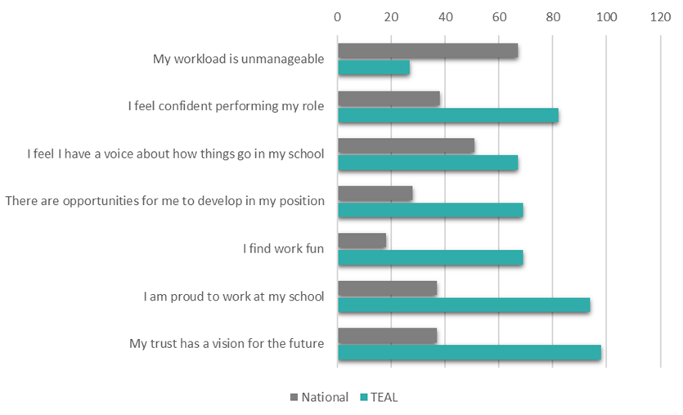
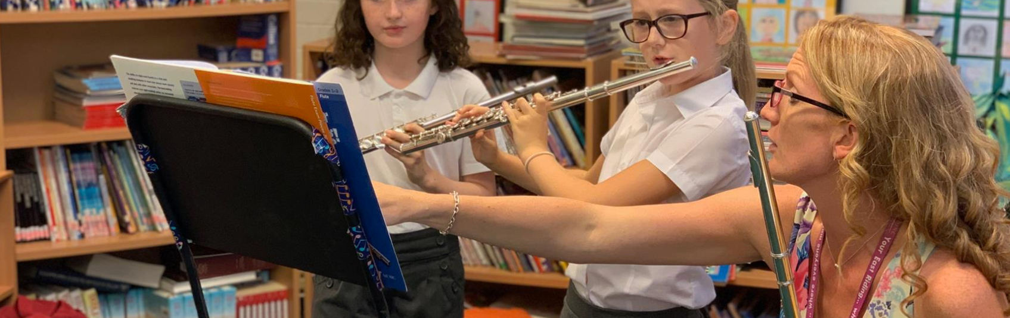

“My role allows me to work across TEAL, supporting all of our schools alongside collaborating on projects with a variety of stakeholders. Projects can start from the due diligence stage and it is great to have the opportunity to work with incoming schools from an early stage. No two days are the same and I continue to learn and gain experience from every new school that joins the TEAL family.”
Francesca Roper, Director of Trust Development and Compliance

What does Ofsted say about TEAL?
 | “Trainees flourish because of the exceptional training that they receive. They get off to the best possible start.”  Ofsted (2024), Yorkshire Wolds Teacher Training

“Governors have taken decisive action to improve the school. This has been successful. Governors know that they have a responsibility to safeguard pupils. They check regularly that safeguarding procedures are effective.”  Ofsted (2021), Howden Junior School | 

 | “Leaders prioritise staff well-being. The school has established a workload and ethical leadership charter. Staff report that this has had notable impact. Staff feel well supported and enjoy working at the school. Staff are supported to develop their expertise through a range of tailored training opportunities. Trustees and governors have a good understanding of the school and hold leaders to account effectively.”  Ofsted (2024), South Hunsley School & Sixth Form

“Staff work very effectively with others in The Education Alliance (TEAL) trust to enhance the experience and opportunities that all pupils have at The Snaith School.”  Ofsted (2022), The Snaith School | 

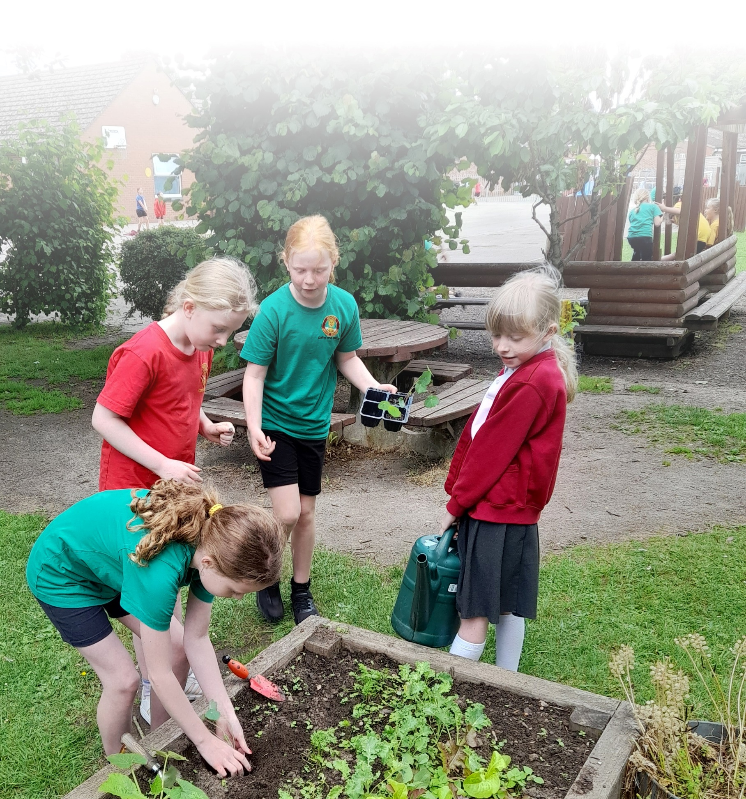
Our Estates

The TEAL family of schools comprises of 12 over 13 sites. Our schools are all incredibly different ranging from listing building facades to brand new DfE purpose built Free Schools.
We have a careful and considered 5-year estates strategy and over recent years, we have made a significant investment in our school buildings to ensure we can deliver a first class learning experience which will equip our students with the skills required for work in the 21st Century. Our estates plan is the key driver for the allocation of our School Conditions Allocation funding from the DfE.



We have well-equipped computer rooms and Wi-Fi access across all schools and all of our sites have fantastic green spaces and sports facilities.

The Recruitment Process
We are offering the date of Wednesday 7th January 2026 for prospective candidates to visit the trust and meet the team and answer any questions you may have (depending on the number of requests, this may be a shared visit with other potential applicants). Likewise, an informal phone call or teams meeting may work for you - please contact us to discuss options via recruitment@theeducationalliance.org.uk or by telephone 01482 631208 Ext 2353.
If you’re unable to complete our online application form and need some support, and/or you
need our documents in an alternative format, for example, large print, please email
recruitment@theeducationalliance.org.uk

We really appreciate the time it takes to complete an application for a job with us. During the shortlisting stage, your application status will be updated on our system and you will receive an automated notification at each stage of the recruitment process. Due to the volume of applications we receive, we’re unable to provide feedback to unsuccessful candidates at the shortlisting stage.
The Education Alliance is committed to safeguarding and promoting the welfare of children and young people. Clearance from the Disclosure and Barring Service is required prior to appointment.

Job Description
Assistant Principal - Primary
Reporting To: Director of Primary Education
Job Purpose
- To actively support our core purpose: “We are here to make great schools and happier, stronger communities so that people have better lives.”

- To work strategically, actively supporting the visions and values of TEAL, providing support to our primary schools with the aim of raising standards of learning and achievement for all students.

- As a key member of the TEAL Senior Leadership Team (SLT), the post holder will collaborate with senior and middle leaders across the Trust to drive strategic priorities, strengthen consistency, maximise shared expertise, and reduce duplication of effort.

- The specific responsibilities and improvement portfolio for this role will be agreed on appointment and reviewed regularly to reflect Trust-wide priorities, as determined by the Director of Primary Education.

Key Responsibilities: Specific
- Lead in the formulation of TEAL’s educational aims, objectives and improvement plans, playing a major role in driving our schools, staff and students towards these goals, and thereby raising standards and improving outcomes.
- Analyse, interpret and triangulate a broad range of data and evidence to diagnose need, shape strategic action plans and evaluate impact with precision and clarity.
- Champion evidence-informed practice, challenging ineffective or outdated approaches in pursuit of excellence and supporting schools to implement sustainable, research-led improvements.
- Collaborate with others in influencing strategic and operational change in a systematic, meaningful, effective way.
- Hold and articulate clear values and moral purpose, focused on providing a world-class education for the students and the wider communities you serve.
- Provide support and challenge to ensure the raising of standards of teaching and learning across TEAL, leading by example, and providing coaching, mentoring and high-quality training as appropriate.
- Strive to maximise pupil progress, including that of our most vulnerable and those educationally disadvantaged, to provide all with the best possible provision.
- Challenge educational orthodoxies in the best interests of achieving excellence, harnessing the findings of well-evidenced research and provide guidance on successful implementation to bring about lasting positive change.
- Lead and manage Trust-wide teams, including Primary Subject Leads (PSLs), ensuring effective collaboration and high standards of professional practice.
- Encourage staff to foster a nurturing culture and to take an active part in the safeguarding of students, ensuring it is given the highest priority and is firmly embedded within all our work.
- Make management and organisational decisions commensurate with the role, referring as appropriate to the Director of Primary Education
- Engage effectively with parents and other members of the community to resolve complaints and develop constructive relationships that support the work of our schools.
- Have high aspirations, striving to maintain and enhance the reputation of the trust and each of its schools as a safe, innovative and forward-thinking learning environment where children and young people thrive and maximise their potential.
- Help build leadership capacity, knowledge and skills across our schools, ensuring long term, sustainable improvements are made by using a collaborative, coaching approach with our school leaders.
- Form part of both the TEAL and your base school’s Leadership Team, attending senior leadership meetings, trust and local governing body meetings and other meetings commensurate with the role.
- Support our schools operationally, standing shoulder to shoulder with all colleagues, in particular in times of greater need and doing the ‘heavy lifting’ as much as possible.

Key Responsibilities: General
- The responsibilities outlined are a broad indication of the main duties and responsibilities of the post and employees will be expected to comply with any reasonable request from a manager to undertake work of a similar level that is not specified in this job description.
- TEAL is committed to safeguarding and promoting the welfare of children, young people and vulnerable adults and expects all employees and volunteers to share this commitment.
- TEAL/The school will endeavour to make any necessary reasonable adjustments to the job and the working environment to enable access to employment opportunities for disabled job applicants or continued employment for any employee who develops a disabling condition.
- The Health and Safety at Work etc. Act, 1974 and other associated legislation places responsibilities for Health and Safety on all employees. Therefore, it is the postholder’s responsibility to take reasonable care for Health and Safety and Welfare of him/herself and other employees in accordance with legislation.
- The above duties may involve having access to information of a confidential nature, which may be covered by GDPR, and by Part 1 of Schedule 12A to the Local Government Act, 1972. Confidentiality must be maintained at all times.
- The postholder must work and process personal and sensitive information in accordance with Data Protection Act 2018 including the General Data Protection Regulations (GDPR) 2018 and to ensure work is conducted in a way that protects the safety and security of information (e.g. strong passwords, reporting breaches, securing paper records, securely disposing of records)

Person Specification
Assistant Principal - Primary
Criteria |  | Evidence | Scoring Method
Qualifications and Experience | Honours degree in relevant specialism | A | Pass/Fail
Qualifications and Experience | Has QTS (before start date) | A | Pass/Fail
Qualifications and Experience | Experience of quality assurance, school improvement planning, and a thorough understanding of change leadership and effective implementation. | A/I | Numerical scale
Qualifications and Experience | Experience of driving whole school or multi-school improvement initiatives that focus on narrowing gaps and improving outcomes. | A/I | Numerical scale
Knowledge and Skills | Has extensive working knowledge of pedagogy, curriculum design and assessment practices across the whole primary phase. | A/I | Numerical scale
Knowledge and Skills | Awareness of barriers faced by disadvantaged and vulnerable pupils and effective strategies to overcome them, using the principles of adaptive teaching to support all | A/I | Numerical scale
Knowledge and Skills | Ability to implement the characteristics of high-quality teaching in line with all Teachers’ Standards, alongside being able to coach, mentor and develop others, supporting reflection, professional growth and improved practice. | A/I | Numerical scale
Knowledge and Skills | Strong leadership and interpersonal skills, with the ability to build trust, credibility and positive relationships quickly. | A/I | Numerical scale
Knowledge and Skills | Highly effective organisational and time management skills, with the ability to balance strategic and operational priorities | A/I | Numerical scale
Values and Behaviours | Makes a commitment to their own professional development in order to become the best teacher and leader they can be. | I | Numerical scale
Values and Behaviours | Demonstrates an ability to build and maintain positive relationships with pupils, colleagues, parents and carers, with a positive outlook and a sense of humour | I | Numerical scale
Values and Behaviours | Makes a commitment to ensuring their values and behaviours align with TEAL’s Ethical Behaviours (as outlined in the Job Description), as commensurate with their role | I | Numerical scale

A = Application (inc. supporting letter) I = assessed during Interview Day(s)
TEAL is committed to safeguarding and promoting the safety and welfare of children and young people and expects all staff to share the commitment. All appointments will, therefore, be subject to a satisfactory Enhanced Level Disclosure and Barring Service Clearance as well as all other relevant pre-employment vetting checks.


The Education Alliance
East Dale Road
Melton
North Ferriby
HU14 3HS


01482 636720


theeducationalliance.org.uk

