

Applicant Pack
Chief Operations Officer
Contents
Welcome from Scott Ratheram 4
Our Family of Schools 7
Our Way of Working 8
Welcome from Karen Dow 9
(DRAFT) TEAL Strategy 2026 - 2030 10
Be Well 11
What do TEAL Headteachers Say? 12
What Do Our Staff Say About TEAL? 14
Our Estates 15
The Recruitment Process 16
Job Description 18


“We are here to make great schools and happier, stronger communities so that people have better lives.”


Welcome from Scott Ratheram

Thank you for your interest in The Education Alliance. We hope this applicant pack will give you a flavour of who we are, what we stand for, and our emerging strategic goals.

We are clear about our mission: we are here to make great schools and happier, stronger communities so that people have better lives.

Our work is grounded in a shared set of values that underpin how we behave, how we lead and how we connect across our schools.

We serve with integrity:

 |  | 
Focussing on young people  to inform our decisions | Prioritising collaboration  to do our best work | Committing to excellence  in all that we do

Inclusion runs through the heart of everything we – the employees of The Education Alliance - do. It shapes our practices in and out of the classroom, informs our curriculum, guides our interactions and underpins our relationships. By placing inclusion at the centre of our vision, we aim to ensure that every child feels seen, heard, supported and respected. Inclusion is more than a statement of intent; it is an ongoing commitment to equity and justice.

This commitment to inclusion extends to our staff culture. TEAL is a friendly and welcoming place to work. Knowing that we all benefit when everyone feels valued and that they belong, and where our work is rewarding and manageable, leaders do all they can to reduce levels of stress and anxiety in the organisation. We believe people want to do a good job and create a culture where openness, professional trust and kindness are the norm.

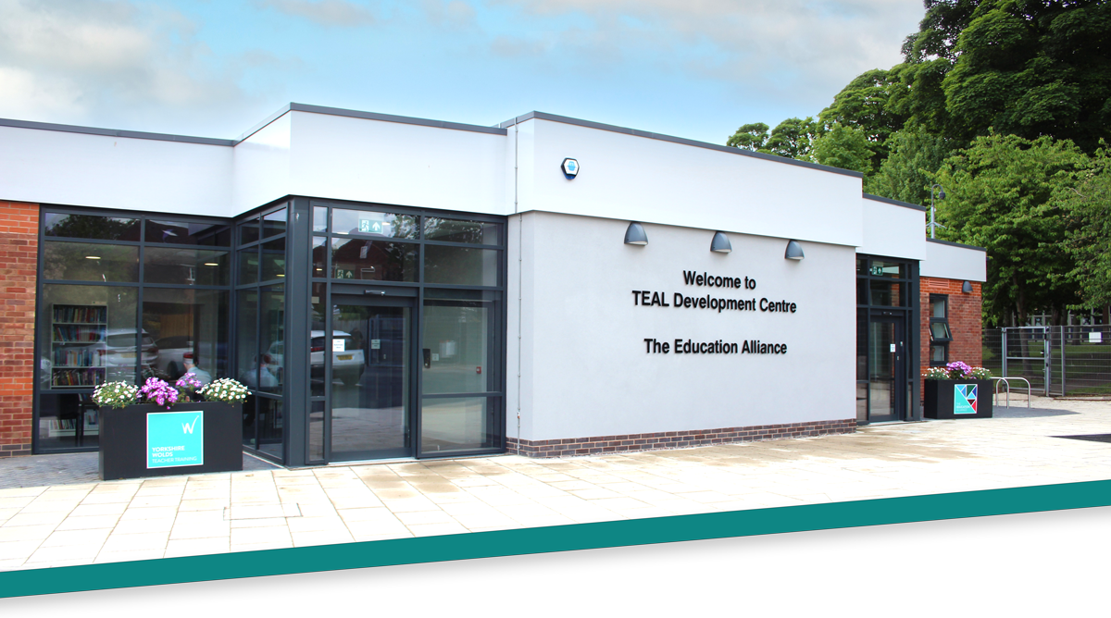

Collaboration is central to how we operate, enabling us to learn from each other to unearth the best ideas. As a family of 12 distinctive schools and a SCITT, we work closely together to establish shared strategic priorities that help us overcome our collective barriers. Through this, we reduce duplication and ease workload for staff, creating the conditions for everyone to do their best work. By utilising our scale thoughtfully and sharing expertise, we ensure that more children, families and communities benefit from the education and support we provide.

We are proud of the work that our SCITT (Yorkshire Wolds Teacher Training) does in developing the next generation of great teachers. Having a great teacher in every class is a powerful lever for advancing social justice; we know this is what all our pupils need and deserve. As such, teacher development is a core component of our improvement strategy, with professional development being both an entitlement and a commitment for each of us.

At TEAL, we design our schools to be inclusive so that all pupils – regardless of their identity, background or starting point – can access the right support at the right time, knowing that they belong and matter. As such, we are clear that education encompasses more than what happens in the classroom. Our schools are rooted in their communities and built on strong relationships. We want young people to feel known, safe and valued, to experience the joy of childhood and to develop the confidence and character they need for the next stage of their lives.

Above all, TEAL is about people (our pupils, our staff and our communities). If you are looking to join a friendly, values-driven organisation, where what you do truly makes a difference, we would love to have you on board.


Scott Ratheram
CEO, The Education Alliance
About The Education Alliance

The Education Alliance Multi-Academy Trust was established in 2015 so that South Hunsley School and Sixth Form College could support the setting up of Hunsley Primary School, the East Riding’s first Free School. Since then, a further ten schools from across the region have joined.
The trust is predominantly based in the East Riding of Yorkshire. Being in such proximity to each other ensures that we can share expertise and resources effectively.
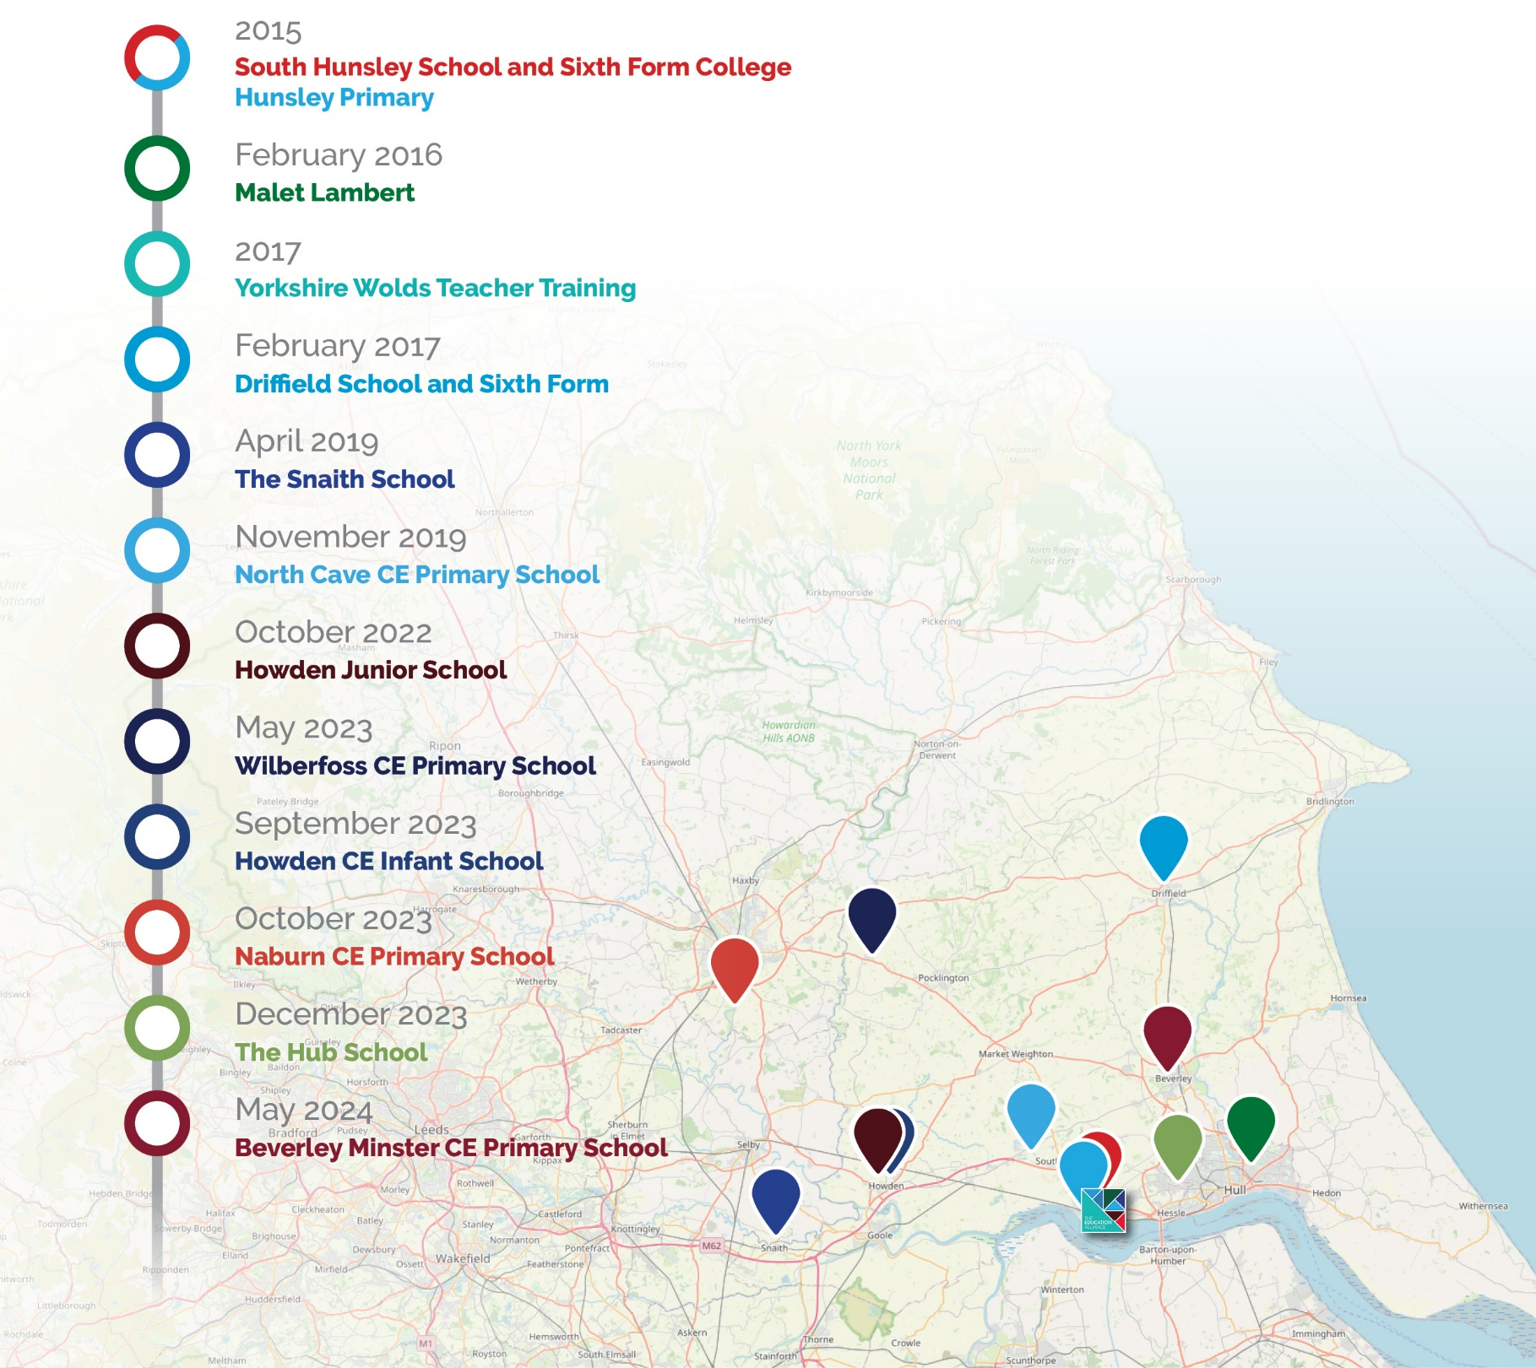

Our Family of Schools
7271
Children on roll

1183  Primary | 5495  Secondary |  | 593  Post-16
 |  |  | 
621  56% Associate Staff |  | 479  44% Teaching Staff
1100
Members of staff

Meet our people
theeducationalliance.org.uk/meet-the-team

Our Way of Working
As a family of distinctive schools, relationships and collaboration are at the heart of our operating model. We recognise people do their best work when they feel listened to, valued and engaged in decision-making. Our aim is to ensure colleagues have agency in their work, intentionally designing our staffing structures and operational calendars to support meaningful professional networks. We are clear that everyone has a responsibility to participate in these communities (sharing expertise, learning from one another and unearthing the very best ideas together, whilst reducing the duplication of effort).
Our Shared Services teams are employed centrally to help our schools thrive. We work closely alongside school leaders and colleagues, listening to their insights, understanding their challenges and building trusting relationships that enable us to shape our services around schools’ needs. This allows us to undertake the ‘heavy lifting’ without diminishing local engagement, reducing the administrative burden on schools and enabling leaders to focus on education.
Our approach combines the benefits of economies of scale with the importance of local leadership. Rather than operating separately from our schools, we bring the right people together at the right time to co-design practical, responsive solutions that reflect the realities of school life. As those needs evolve, we continue to adapt our services, providing the most effective support whilst maintaining local engagement and respecting each school’s individual context, identity and strengths.
We continue to learn how important it is to listen, consult widely and avoid making assumptions. We recognise that our best work is shaped through collaboration, professional dialogue and shared understanding. By drawing on the expertise that exists across our schools, we are able to develop aligned solutions whilst enabling schools to retain the flexibility needed to respond effectively to the needs of their communities.
As one team, we share expertise, support one another and prioritise building trusting relationships where people feel connected and supported. This is not a ‘nice to have’, but a necessity: we seek to ensure that every colleague feels a strong sense of belonging to both their school and the wider organisation.
We invite you to explore our Trust Charters below and discover what it means to be part of TEAL.
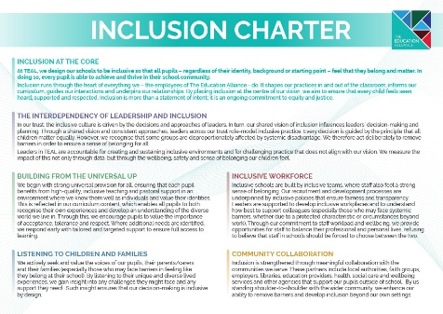 | 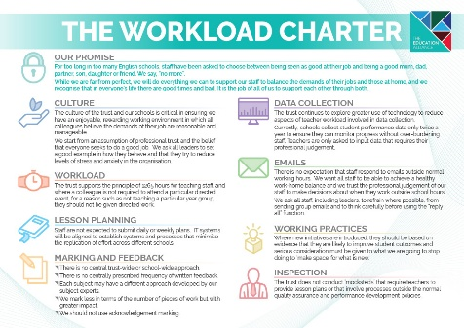 | 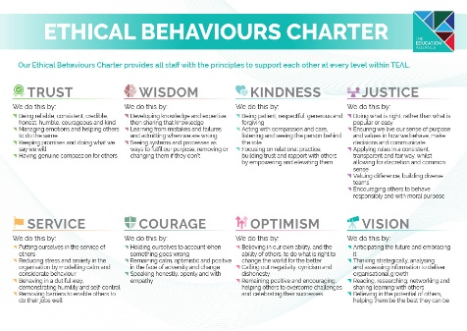
Inclusion Charter | Workload Charter | Ethical Behaviours Charter
(Click the charter image to be taken to our website.)



Welcome from Karen Dow

I am delighted you are interested in becoming part of our TEAL family. I have been involved in this trust since the beginning and have been a governor in three of our schools and served as chair of the local governing bodies of both South Hunsley School and Driffield School. I know that you will find it to be a thoroughly enjoyable and rewarding experience.
In our trust, we take governance very seriously and we are fortunate in having a highly motivated, skilled and experienced group of people in all of our schools. In return, you will find that you are highly valued by school leaders and indeed all staff. In addition, governors have regular opportunities for development and training and to meet colleagues from other schools and across the trust. Many governors also regularly get involved in school activities and get to meet our wonderful young people.

Karen Dow
Chair of the Board of Trustees



(DRAFT) TEAL Strategy 2026 - 2030
Our Purpose
We are here to make great schools and happier, stronger communities so that people have better lives

Our Core Values
We serve with integrity:
- Focussing on young people to inform our decisions
- Prioritising collaboration to do our best work
- Committed to excellence in all that we do

Our Work and Services
- We work together as a family of distinctive schools, pooling our expertise to train our workforce and to deliver high‑quality, inclusive education.
- We provide a sustainable pipeline for the next generation of great teachers and leaders.
- We work in partnership to provide professional operational services that support our schools.
- We foster strong relationships and ensure we remain deeply connected to the communities we serve, supporting all children to belong, achieve and thrive.

Our Long-Term Strategic Goals
1. | We will be a beacon of inclusive education, where every child receives the right support at the right time to achieve and thrive.
2. | We will elevate learning for all through adaptive teaching that is inclusive by design and consistently responsive to need.
3. | We will be a trust rooted in relationships and communities, so that young people know they belong, experience the joy of childhood, and develop a strong foundation for life.
4. | We will reinvent our shared services - co‑designed with schools as true partners - to deliver operational excellence, enabling leaders to focus on education.
5. | We will develop the next generation of great teachers and invest in all our people, harnessing our collective expertise to provide evidence‑informed development for every role and career stage.
6. | We will amplify our impact through intentional growth, building on the reputation of our schools’ achievements and our position as an employer of choice, leveraging our scale to reduce workload and unearth the best ideas together.


Be Well
The Be Well programme delivers a whole school approach to supporting mental health and wellbeing for pupils, parents/carers and staff across the trust.
The trust invests £500,000 a year from its TEAL Social Value company (not from top slice) to provide the following services to our schools:
Hull and East Yorkshire Mind Whole School Approach
HEY Mind provides dedicated time for a Mind professional to work within our primary and secondary schools to implement a range of interventions and training from their menu. This includes: a drop-in facility for pupils and staff; support and training for staff (e.g. Youth Mental Health First Aiders and how to have a conversation about mental health); pupil resilience intervention training; pupil Well-Being Ambassador training; and more intensive support through the Big Umbrella programme.
Listen Loud
Listen Loud is an outreach intervention programme delivered by The HUB School. It offers a supportive space where pupils can connect, share, and learn valuable skills to enhance their educational journey, enabling them to build confidence, develop communication skills and promote their own achievement. This programme is designed to create a sense of belonging, encouraging pupils to engage with their peers and learn from each other in a safe environment. In doing so, it helps pupils develop and secure the tools they need to enhance their wellbeing, both now and in the future.
Since its launch in October 2024, 224 pupils have been supported through the ‘Listen Loud’ programme, with positive feedback received around how this new provision has landed in our schools.
Emotional Literacy Support Assistant (ELSA) Intervention
Each primary school benefits from additional staffing to increase mental health and wellbeing support (for pupils, their parents/carers and our staff), in a responsive and proactive way.
Social Prescribing
Youth social prescribing is relatively new initiative offered by Yorkshire Health Partners, aimed at secondary-age children. The aim is to support young people access a range of support and services to improve their wellbeing. This service targets support around low-level anxiety, including anxiety-based school avoidance. Since March 2025, the Be Well programme has funded the equivalent of two full-time social prescribers across our secondary schools and we are hearing great feedback.

What do TEAL Headteachers Say?
“Being new to headship, the amount of support, reassurance, and encouragement I have been given in my first year has been fantastic. This support is readily available from the wider trust team and our team of headteachers whenever I need advice. Being part of a group of schools means that you are never alone; there is always someone on hand to offer guidance. There is a vast amount of collaboration, creativity and sharing of ideas and resources. There are absolutely no egos, or competition: everyone works together with the ultimate aim of increasing life chances for our pupils (and by our pupils, I mean TEAL pupils). The expertise shared across TEAL takes place at all levels, making everyone’s lives easier, reducing the duplication of effort and therefore lessening the workload of everyone. At the same time, this expertise ensures that everyone can further develop and become better at what they do, whatever their role in school. I can honestly say I would not be a headteacher anywhere else other than TEAL.”
Heather Yates

“Our school joined the Education Alliance in November 2019 and since then we have benefited immensely from working within the Trust. The support has been invaluable on many different levels. Our staff really appreciate working collaboratively with other colleagues within TEAL to develop our curriculum and share training. We have also really valued the support we have received in other areas, such as finance, HR, catering, and premises. We are excited to be part of TEAL as we continue to enhance the opportunities for our children.”
Richard Winks

“Some say that headship can be a ‘lonely place’, at times. Not in The Education Alliance! Malet Lambert was lucky to be one of the first schools to join TEAL. The support we receive as a school from the central team has been crucial in our development. Much of the ‘heavy lifting’ is taken away from schools, which means my leadership team and I can focus more on the day-to-day running of the school, whilst working alongside trust colleagues strategically. The trust has assisted us in the development of the school, whether it be our curriculum offer, value for money procurement or sustainability. The skillset in the trust team is strong and varied. The size of the trust also allows a very personal offer, where everyone knows everyone else and you very much feel like a valued school, rather than just a number. Malet Lambert is a very proud member of TEAL, as am I as a headteacher.”
Patrick Sprakes

“South Hunsley School was the founding school of TEAL and from those early days, the trust has grown in size and reputation. Leading ethically, collaborating at all levels, committing to professional development and reducing workload are just a few of the reasons why I chose to apply for a second headship within the trust. Despite some of the challenges we face in schools, I enjoy my job enormously. What can be more rewarding than seeing young people happy and successful? The accountability is high, but we work in a culture of low threat and professional trust, resulting in me feeling highly motivated, challenged and supported to do the best job I can for the benefit of the staff, young people and wider community that we serve.”
Michaela Blackledge


“As headteacher of Hunsley Primary, I have always felt the strength of collaboration and shared moral purpose across the trust's schools to be a powerful support in all aspects of my role. Schools and their leaders will always face both opportunities and challenges - often in equal measure - and it is inspiring to know that no leader in the trust works alone. Instead, we work positively and creatively across a wide team to share one another's successes and to offer thoughtful solutions to questions, inspired by the same values. As a group of headteachers, our collective understanding and experience mean that we draw on each other readily, in a proper spirit of support and mutual respect.”
Lucy Hudson

“As a new headteacher, being part of TEAL is invaluable. I am part of a wider team of headteachers who I am able to share ideas with, seek advice from and, ultimately, this helps to improve the experiences for all our young people. The advantage of working as a group of schools is that we can share ideas and resources which reduce workload and make people’s lives easier. This reduces the duplication of effort across TEAL and helps us take full advantage of the expertise we have in all of our schools. A wide range of similar groups work together regularly, including whole-school curriculum leaders, pastoral leaders and SENDCos. Whatever your role in TEAL, the opportunity to work with other people across our schools helps us to secure the best experience for our pupils, whilst keeping workload as manageable as possible.”
Vicky Loftus

“Since joining the Education Alliance in December 2023, I can confidently say it has made our school, and the communities it serves, a much better experience for staff, pupils and their families. We chose to join TEAL as their values around ethical leadership, ‘doing the right thing’ and servant leadership aligned with ours. They have now become lived experiences for us and the support for me as Executive Headteacher and the staff team across the school is significantly positive. Senior leaders have fantastic opportunities to collaborate, work strategically and share experiences. The value TEAL places on people, their wellbeing and happiness is a constant thread, woven into everyday working life. This, alongside the young people we work with, is always the ‘driver’ of decisions and changes. As a leader, I feel the opportunity to reach out for advice or support is the most powerful resource TEAL have offered. This allows me to focus on the things that will make the biggest difference to the school and the pupils in it.”
Paul Grimes

“We joined TEAL in May 2024 and have continued to receive excellent support and positivity. As a headteacher, it is very difficult to keep plates spinning, and to know that there is always someone there to help when you need it can be all you need. The services TEAL offer are extremely professional and a vital support with the very difficult 'heavy lifting' that is inevitable in such a diverse role. The range of people that we can seek support from, combined with the depth of knowledge and experience behind that, means that I can prioritise the most important aspects of my role. There is a definite purpose and clear mission enacted by TEAL; as headteachers, we work closely together to improve outcomes for children and the communities we serve. Having recently exited the maintained system (where it can be difficult to work so closely together with other schools), I can see how powerful this united approach will be in fulfilling our core purpose. I am looking forward to seeing how our journey progresses.”
Luke Fletcher

What Do Our Staff Say About TEAL?
We regularly gather staff voice, including considering workload and well-being. This includes annual review against the questions used by the TES Wellbeing Report.

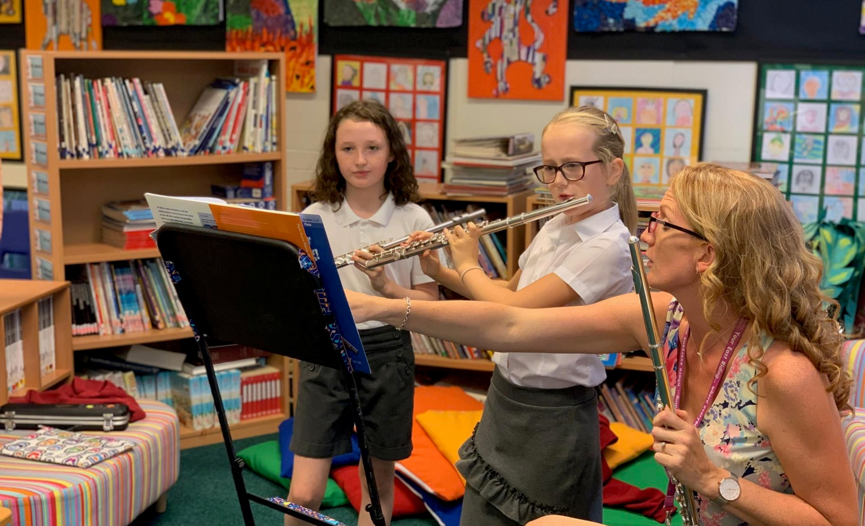
“My role allows me to work across TEAL, supporting all of our schools alongside collaborating on projects with a variety of stakeholders. Projects can start from the due diligence stage and it is great to have the opportunity to work with incoming schools from an early stage. No two days are the same and I continue to learn and gain experience from every new school that joins the TEAL family.”
Francesca Roper, Director of Compliance, Growth and Governance


Our Estates
The TEAL family of schools comprises of 12 over 13 sites. Our schools are all incredibly different, ranging from listed building facades to brand new purpose-built Free Schools.

We have a careful and considered 5-year estates strategy and, over recent years, we have made a significant investment in our school buildings to ensure we can deliver a first-class learning experience which will equip our pupils with the skills required for work in the 21st Century. Our estates plan is the key driver for the allocation of our School Conditions Allocation funding from the DfE.

We have well-equipped computer rooms and Wi-Fi access across all schools as well as fantastic green spaces and sports facilities across our sites.


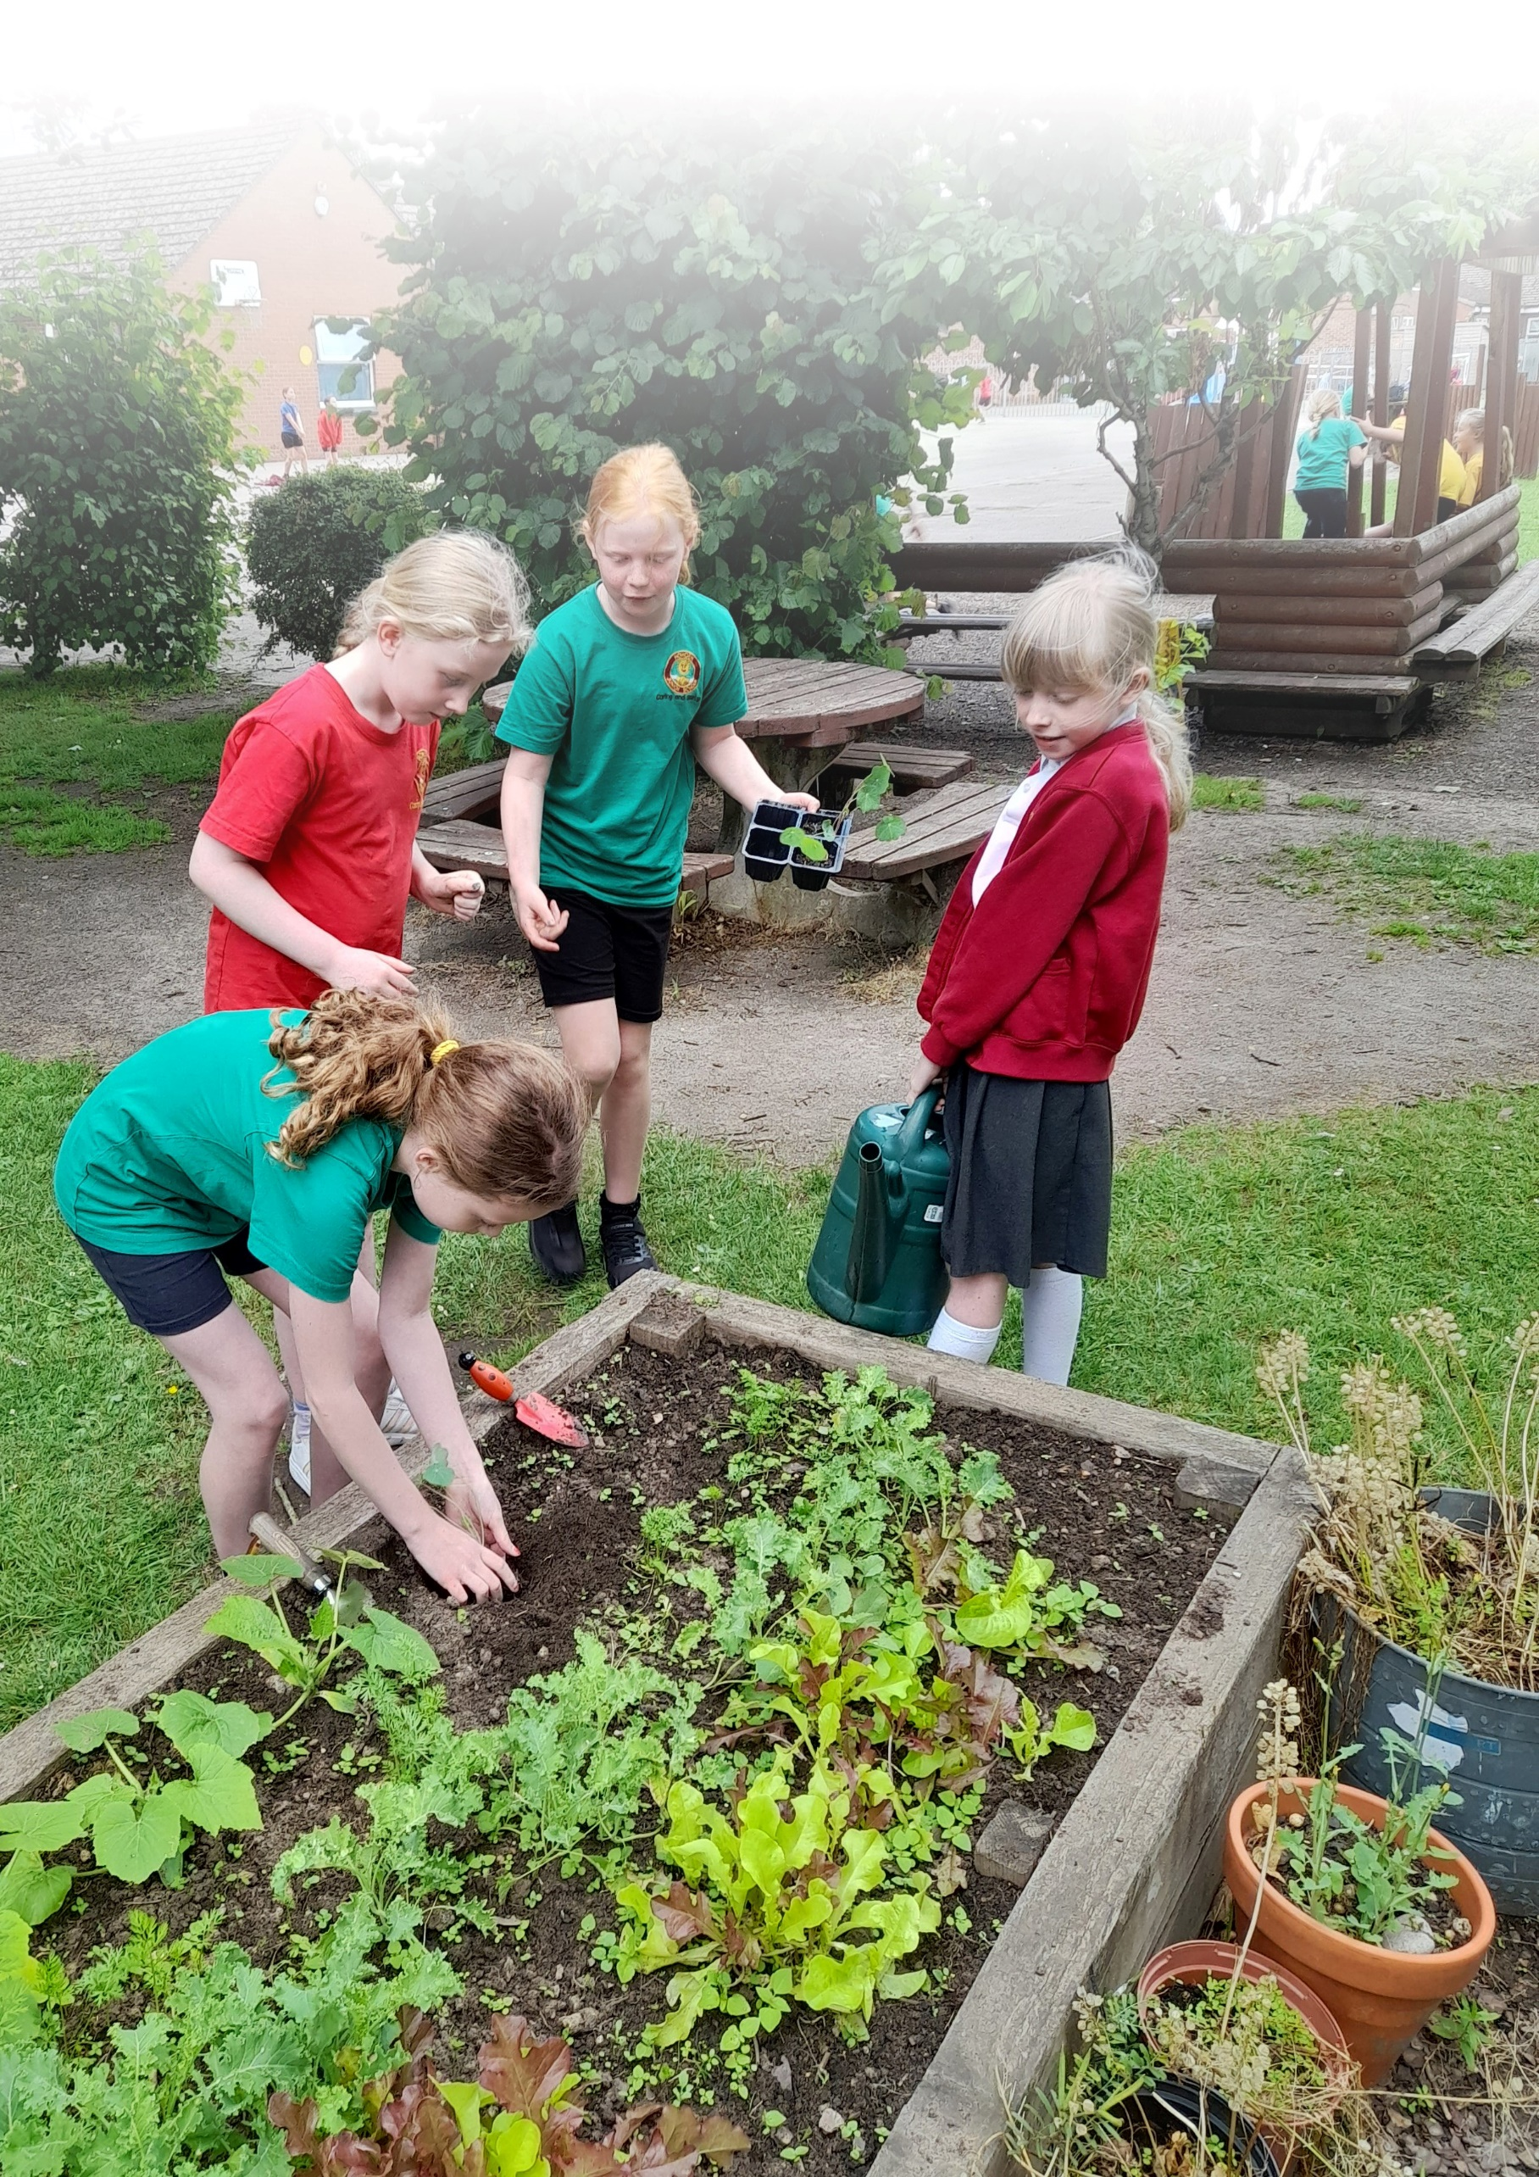

The Recruitment Process
“Having previously worked for large private businesses, I was excited to start in a brand-new sector. I knew it would be a fantastic learning opportunity to work amongst a variety of colleagues and schools, building my skillset and knowledge in a new area. Working for TEAL has given me a fantastic work-life balance, as I am able to work predominantly term-time only, allowing me to spend more time with my young family, which is priceless. I have built many positive relationships, and thoroughly enjoy coming to work every day!”
Lisa Cunningham, Assistant Director of Finance
All applications must be received by 9.00am on the 21 September. We are offering the dates of Tuesday 8 and Friday 18 September for prospective candidates to visit the trust, and meet the team and answer any questions you may have (depending on the number of requests, this may be a shared visit with other potential applicants). Likewise, a phone call or teams meeting may work for you - please contact Vic Dent via victoria.dent@theeducationalliance.org.uk.
Interviews are expected to take place the week beginning 28 September at the TEAL Development Centre, Melton.
If you’re unable to complete our online application form and need some support, and/or you need our documents in an alternative format (for example, large print) please email recruitment@theeducationalliance.org.uk.
We really appreciate the time it takes to complete an application for a job with us. During the shortlisting stage, your application status will be updated on our system and you will receive an automated notification at each stage of the recruitment process. Due to the volume of applications we receive, we’re unable to provide feedback to unsuccessful candidates at the shortlisting stage.
The Education Alliance is committed to safeguarding and promoting the welfare of children and young people. Clearance from the Disclosure and Barring Service will be sought prior to appointment and we undertake an online check on all shortlisted candidates, in line with the Keeping Children Safe in Education guidance.
The Education Alliance’s Child Protection Policy can be accessed at: https://theeducationalliance.org.uk/wp-content/uploads/Child-Protection-Policy.pdf.

Job Description
Job Description: Chief Operations Officer Reporting To: CEO
Job Purpose
The Chief Operations Officer (COO) is a key senior executive leader within The Education Alliance (TEAL), responsible for designing, leading and continuously improving a high-quality, people-centred shared services function that enables educational excellence across all schools in the trust.
Working closely with the CEO, school leaders, directors and trustees, the COO will ensure that services are co-designed with schools as true partners, delivering operational excellence while maintaining school agency and trust-wide coherence.
The COO will provide strategic leadership across all operational areas, ensuring systems, processes and services are efficient, effective and responsive – enabling our schools to thrive. Through strong relationships, deep professional expertise and a focus on quality improvement, the COO will ensure that TEAL’s operational services are solution-focused and responsive, allowing headteachers and leaders to focus on what matters most: education, pupils and communities.
Key Responsibilities: Specific
- Provide strategic operational leadership across the trust, ensuring alignment with the trust’s vision, values and strategic priorities.
- Work in close partnership with the CEO to shape, deliver and monitor the TEAL Strategy, driving continuous organisational improvement.
- Build strong, credible relationships with headteachers, leaders and school teams, acting as a key link between schools, executive leaders and trustees.
- Lead a culture of collaboration, ensuring schools feel heard, supported and valued in all operational decision-making.
- Develop and lead a high-performing shared services team, building capacity, capability and strong collaboration with school-based colleagues.
- Lead and co-ordinate all operational functions, including finance, HR, facilities and estates, IT, and health & safety, ensuring services are high-quality, efficient and responsive, enabling schools to be successful, inclusive and safe environments for all pupils and staff.
- Establish shared services as trusted, solution-focussed partners, balancing trust-wide consistency with appropriate local autonomy.
- Ensure high-quality professional development for our operational teams to enable every member of staff - regardless of role or career stage - to continually improve their practice and progress into new roles.
- Support robust financial planning, oversight and sustainability, working closely with the CFO to align resources with trust and school priorities.
- Support the development of clear and well-understood career pathways, alongside sector-leading professional development for every role, to enable every member of staff - regardless of role or career stage - to continually improve their practice and to deliver their best work.
- Oversee operational risk management and business continuity planning and testing.
- Build and maintain strong relationships with external stakeholders and support our trust growth strategy.
- Attend and contribute to Board of Trustees and committee meetings when required, providing clear, accurate and timely operational reporting.
- Promote a culture where staff feel supported, valued and engaged; championing staff wellbeing across all operational services and enabling sustainable improvement across the trust.
- Consistently demonstrate the behaviours outlined in our Ethical Behaviours Charter overleaf and undertake any other work commensurate with the post.
Key Responsibilities: General
- The responsibilities outlined are a broad indication of the main duties and responsibilities of the post and employees will be expected to comply with any reasonable request from a manager to undertake work of a similar level that is not specified in this job description.
- TEAL is committed to safeguarding and promoting the welfare of children, young people and vulnerable adults and expects all employees and volunteers to share this commitment.
- TEAL will endeavour to make any necessary reasonable adjustments to the job and the working environment to enable access to employment opportunities for disabled job applicants or continued employment for any employee who develops a disabling condition.
- The Health and Safety at Work etc. Act, 1974 and other associated legislation places responsibilities for Health and Safety on all employees. Therefore, it is the postholder’s responsibility to take reasonable care for Health and Safety and Welfare of him/herself and other employees in accordance with legislation.
- The above duties may involve having access to information of a confidential nature, which may be covered by GDPR, and by Part 1 of Schedule 12A to the Local Government Act, 1972. Confidentiality must be maintained at all times.
- The postholder must work and process personal and sensitive information in accordance with Data Protection Act 2018 including the General Data Protection Regulations (GDPR) 2018 and to ensure work is conducted in a way that protects the safety and security of information (e.g. strong passwords, reporting breaches, securing paper records, securely disposing of records)

Ethical Behaviours Charter
Competency | We do this by:
Trust | - Being reliable, consistent, credible, honest, humble, courageous and kind.  - Managing emotions and helping others to do the same.  - Keeping promises and doing what we say we will  - Having genuine compassion for others
Wisdom | - Developing knowledge and expertise, then sharing that knowledge  - Learning from mistakes and failures and admitting when we are wrong  - Seeing systems and processes as ways to fulfil our purpose, removing or changing them if they fail in that.
Kindness | - Being patient, respectful, generous and forgiving.  - Acting with compassion and care, listening and seeing the person behind the role  - Focusing on relational practice; building trust and rapport with others by empowering and elevating them.
Justice | - Doing what is right, rather than what is popular or easy  - Ensuring we live our sense of purpose and values in the way we behave, make decisions and communicate.  - Applying rules in a consistent, transparent and fair way, whilst allowing for discretion and common sense.  - Valuing difference, building diverse teams and encouraging others to behave responsibly and with moral purpose.
Service | - Putting ourselves in the service of others.  - Reducing stress and anxiety in the organisation by modelling calm and considerate behaviour  - Behaving in a dutiful way, demonstrating humility and self-control.  - Removing barriers to enable others to do their jobs well
Courage | - Holding ourselves to account when something goes wrong.  - Remaining calm, optimistic and positive in the face of adversity and change.  - Speaking honestly, openly and with empathy
Optimism | - Believing in our own ability, and the ability of others, to do what is right to change the world for the better.  - Calling out negativity, cynicism and dishonesty.  - Remaining positive and encouraging, helping others to overcome challenges and celebrating their success.
Vision | - Anticipating the future and embracing it. Thinking strategically, analysing and assessing information to deliver organisational growth.  - Reading, researching, networking and sharing learning with others.  - Believing in the potential of others; helping them be the best they can be.

Person Specification
Criteria |  | Evidence | Scoring Method
Qualifications and Experience | Graduate in relevant specialism and/or qualifications specific to the role | A | Y/N
Qualifications and Experience | Substantial senior leadership experience in operations in a complex, multisite organisation (ideally a MAT, public sector, or similar environment) | A | Y/N
Qualifications and Experience | Proven track record of leading organisational change and transformation programmes, including service redesign projects | A/I | Numerical Scale
Qualifications and Experience | Experience in analysing data, developing strategic plans, setting targets and monitoring/evaluating progress to lead organisational development and improvement | A/I | Numerical Scale
Qualifications and Experience | A clear understanding of the current educational landscape, including issues specifically relating to the operation of multi academy trusts | A/I | Numerical Scale
Qualifications and Experience | Extensive and recent experience of leading, managing and co-ordinating multi-professional teams (e.g. HR, estates, IT/digital, finance and compliance) through an effective and collaborative approach | A/I | Numerical Scale
Qualifications and Experience | Understanding of strategies for performance management, including distributive leadership and building teams to share accountability for goals and standards | A/I | Numerical Scale
Qualifications and Experience | Evidence of building and leading high-performing teams and developing staff | A/I | Numerical Scale
Knowledge and Skills | Demonstrates the ability to work both independently and collaboratively, adapting flexibly to meet organisational needs | A/I | Numerical scale
Knowledge and Skills | Proven capability to lead operational functions, ensuring safe, secure and well-managed environments, with a strong understanding of the legal and regulatory framework within education and charities sector | A/I | Numerical scale
Knowledge and Skills | An excellent communicator and influencer, able to engage, motivate and inspire a wide range of audiences both within and beyond the organisation | A/I | Numerical scale
Knowledge and Skills | Confident and skilled in presenting complex information clearly and engagingly, with strong emotional intelligence and professional judgement | A/I | Numerical scale
Knowledge and Skills | Understanding of financial acumen and commercial awareness, including contracts, value-for-money and procurement | A/I | Numerical scale
Knowledge and Skills | Demonstrates an innovative and forward-thinking mindset, with a strong focus on achieving impact and delivering results | A/I | Numerical scale
Knowledge and Skills | Committed to acting in the best interests of our schools, maintaining integrity in all decision-making | A/I | Numerical scale
Knowledge and Skills | Resilient and confident in managing challenge, with the ability to handle conflict constructively and effectively | A/I | Numerical scale
Knowledge and Skills | Able to make thoughtful, well-judged decisions that strengthen and sustain a positive trust culture | A/I | Numerical scale
Values and Behaviours | A deep commitment and motivation to education and operational excellence | A/I | Numerical scale
Values and Behaviours | Demonstrates an ability to build and maintain positive relationships with pupils, colleagues, parents/carers, trustees and external stakeholders. | A/I | Numerical scale
Values and Behaviours | Strong alignment with TEAL’s values of trust, integrity, collaboration, staff wellbeing and the focus on young people to inform our decisions | A/I | Numerical scale

A = Application (inc. supporting letter), I = assessed during Interview Day(s)
TEAL is committed to safeguarding and promoting the safety and welfare of children and young people and expects all sta. to share the commitment. All appointments will, therefore, be subject to a satisfactory Enhanced Level Disclosure and Barring Service Clearance as well as all other relevant pre-employment vetting checks.




The Education Alliance
East Dale Road
Melton
North Ferriby
HU14 3HS


01482 636720


theeducationalliance.org.uk

